 | BC  UNEP/CHW/OEWG/3/INF/14
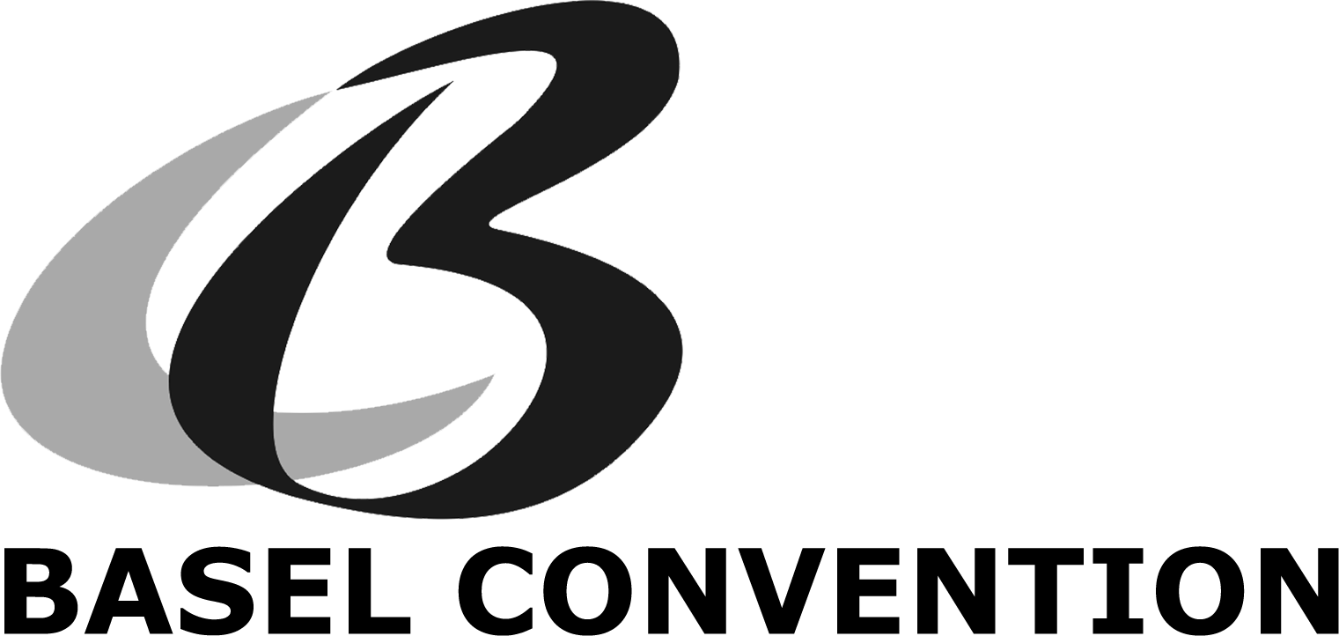 |  | Distr.: General  28 February 2004  English only
Open-Ended Working Group of the Basel Convention
on the Control of Transboundary Movements of
Hazardous Wastes and Their Disposal
Third session
Geneva, 26-30 April 2004
Item 13 (b) of the provisional agenda∗
Annexes to the Basel Convention and related procedures:
National classification and control procedures for the
import of wastes contained in Annex IX

Annex IX to the Basel Convention

Responses provided by Parties

Enclosed are responses provided by Parties on the questionnaire concerning the national classification and control procedures for the import of wastes contained in Annex IX (List B wastes) using for this purpose the questionnaire adopted by the sixth meeting of the Conference of the Parties (decision VI/19).

Contents

Page

Bahrain 3-22

Bulgaria 23-46

China 47-66

Egypt 67-85

Poland 86-105

Bahrain

Questionnaire

Cover sheet - general information:
-> Please fill in the following:

Country:  Bahrain | Address:  Environmental Affairs  General Commission for the Protection of Marine Resources, Environment & Wildlife  P.O.Box 32567-Isa Town
Contact person:  Abdul Mohsin Al-Mahmood  Head of Waste Management Section | Remarks
Telephone no:  00 973 1 7875163 | E-mail:  Mohsin602000@yahoo.com
Fax no:  00973 786102 | Date when questionnaire completed D/M/Y:  27 December 2003

To request an electronic version of this questionnaire, to return the completed questionnaire, or for further information, clarification or assistance, please contact:

Mr Ibrahim Shafii
Secretariat of the Basel Convention SBC
15, chemin des Anémones
1219 Châtelaine, Geneva
Switzerland
Tel: (41 22) 917 8636; Fax: (41 22) 797 3454
E-mail: ibrahim.shafii@unep.ch

1.  Annex IX of the Basel Convention  (List B) |  | 2.  National classification and control procedure for the import of wastes listed in Annex IX (list B) of the Basel Convention |  |  |  | 3.  Country:  Bahrain
1.a  Code | 1.b  Waste | 2.a  Art. 1(1)b waste | 2.b  No control procedure | 2.c  PIC -Procedure | 2.d  Import prohibited | 4.  Comments and information (1)
B1 | Metal and metal-bearing waste
B1010 | Metal and metall-alloy waste in metallic, non dispersible form:  - precious metals (gold, silver, the platinum group, but not mercury) |  | x
B1010 | Metal and metal-alloy waste in metallic, non dispersible form:  - Iron and steel scrap |  | x
B1010 | Metal and metal-alloy waste in metallic, non dispersible form:  - Copper scrap |  | x
B1010 | Metal and metal-alloy waste in metallic, non dispersible form:  - Nickel scrap |  | x
B1010 | Metal and metal-alloy waste in metallic, non dispersible form:  - Aluminum scrap |  | x
B1010 | Metal and metal-alloy waste in metallic, non dispersible form:  - Zinc scrap |  | x
B1010 | Metal and metal-alloy waste in metallic, non dispersible form:  - Tin scrap |  | x
B1010 | Metal and metal-alloy waste in metallic, non dispersible form:  - Tungsten scrap |  | x
B1010 | Metal and metal-alloy waste in metallic, non dispersible form:  - Molybdenum scrap |  | x
B1010 | Metal and metal-alloy waste in metallic, non dispersible form:  - Tantalum scrap |  | x
B1010 | Metal and metal-alloy waste in metallic, non dispersible form:  - Magnesium scrap |  | x
B1010 | Metal and metal-alloy waste in metallic, non dispersible form:  - Cobalt scrap |  | x
B1010 | Metal and metal-alloy waste in metallic, non dispersible form:  - Bismuth scrap |  | x
B1010 | Metal and metal-alloy waste in metallic, non dispersible form:  - Titanium scrap |  | x
B1010 | Metal and metal-alloy waste in metallic, non dispersible form:  - Zirconium scrap |  | x
B1010 | Metal and metal-alloy waste in metallic, non dispersible form:  - Manganese scrap |  | x
B1010 | Metal and metal-alloy waste in metallic, non dispersible form:  - Germanium scrap |  | x
B1010 | Metal and metal-alloy waste in metallic, non dispersible form:  - Vanadium scrap |  | x
B1010 | Metal and metal-alloy waste in metallic, non dispersible form:  - Scrap of Hafnium, Indium, Niobium, Rhenium and Gallium |  | x
B1010 | Metal and metal-alloy waste in metallic, non dispersible form:  - Thorium scrap |  | x
B1010 | Metal and metal-alloy waste in metallic, non dispersible form:  - Rare earth’s scrap |  | x
B1020 | Clean uncontaminated metal scrap, including alloys, in bulk finished form (sheet, plate, beams, rods, etc.), of:  - Antimony scrap |  | x
B1020 | Clean uncontaminated metal scrap, including alloys, in bulk finished form (sheet, plate, beams, rods, etc.), of:  - Beryllium scrap |  | x
B1020 | Clean uncontaminated metal scrap, including alloys, in bulk finished form (sheet, plate, beams, rods, etc.), of:  - Cadmium scrap |  | x
B1020 | Clean uncontaminated metal scrap, including alloys, in bulk finished form (sheet, plate, beams, rods, etc.), of:  - Lead scrap (but excluding lead-acid batteries) |  | x
B1020 | Clean uncontaminated metal scrap, including alloys, in bulk finished form (sheet, plate, beams, rods, etc.), of:  - Selenium scrap |  | x
B1020 | Clean uncontaminated metal scrap, including alloys, in bulk finished form (sheet, plate, beams, rods, etc.), of:  - Tellurium scrap |  | x
B1030 | Refractory metals containing residues |  | x
B1040 | Scrap assemblies from electrical power generation not contaminated with lubricating oil, PCB or PCT to an extent to  render them hazardous |  | x
B1050 | Mixed non-ferrous metal, heavy fraction scrap, not containing Annex I materials in concentrations sufficient to exhibit Annex  III characteristics |  | x
B1060 | Waste selenium and tellurium in metallic elemental form including powder |  | x
B1070 | Waste of copper and copper alloys in dispersible form, unless they contain Annex I constituents to an extent that they exhibit Annex III characteristics |  | x
B1080 | Zinc ash and residues including zinc alloys residues in dispersible form unless containing Annex I constituents in  concentration such as to exhibit Annex III characteristics or exhibiting hazard characteristic H4.3 |  | x
B1090 | Waste batteries conforming to a specification, excluding those made with lead, cadmium or mercury |  | x
B1100 | Metal-bearing wastes arising from melting, smelting and refining of metals:  - Hard zinc spelter |  | x
B1100 | Metal-bearing wastes arising from melting, smelting and refining of metals:  Zinc-containing drosses:  - Galvanizing slab zinc top dross (>90% Zn) |  | x
B1100 | Metal-bearing wastes arising from melting, smelting and refining of metals:  Zinc-containing drosses:  - Galvanizing slab zinc bottom dross (>92% Zn) |  | x
B1100 | Metal-bearing wastes arising from melting, smelting and refining of metals:  Zinc-containing drosses:  - Zinc die casting dross (>85% Zn) |  | x
B1100 | Metal-bearing wastes arising from melting, smelting and refining of metals:  Zinc-containing drosses:  - Hot dip galvanizers slab zinc dross (batch) (>92% Zn) |  | x
B1100 | Metal-bearing wastes arising from melting, smelting and refining of metals:  Zinc-containing drosses:  - Zinc skimmings |  | x
B1100 | Metal-bearing wastes arising from melting, smelting and refining of metals:  - Aluminium skimmings (or skims) excluding salt slag |  | x
B1100 | Metal-bearing wastes arising from melting, smelting and refining of metals:  -Slags from copper processing for further processing or refining not containing arsenic, lead or cadmium to an extend that they exhibit Annex III hazard characteristics |  | x
B1100 | Metal-bearing wastes arising from melting, smelting and refining of metals:  - Wastes of refractory linings, including crucibles, originating from copper smelting |  | x
B1100 | Metal-bearing wastes arising from melting, smelting and refining of metals:  - Slags from precious metals processing for further refining |  | x
B1100 | Metal-bearing wastes arising from melting, smelting and refining of metals:  - Tantalum-bearing tin slags with less than 0.5% tin |  | x
B1110 | Electrical and electronic assemblies:  - Electronic assemblies consisting only of metals or alloys |  | x
B1110 | Electrical and electronic assemblies:  - Waste electrical and electronic assemblies or scrap (including printed circuit boards) not containing components such as accumulators and other batteries included on list A, mercury-switches, glass from cathode-ray tubes and other activated  glass and PCB-capacitors, or not contaminated with Annex I constituents (e.g., cadmium, mercury, lead, polychlorinated biphenyl) or from which these have been removed, to an extent that they do not possess any of the characteristics contained in Annex III (note the related entry on list A A1180) |  | x
B1110 | Electrical and electronic assemblies:  - Electrical and electronic assemblies (including printed circuit boards, electronic components and wires) destined for direct reuse, and not for recycling or final disposal |  | x
B1120 | Spent catalysts excluding liquids used as catalysts, containing any of:  - Transition metals, excluding waste  catalysts (spent catalysts, liquid  used catalysts or other catalysts) on list  A: Scandium, Vanadium, Manganese  Cobalt, Copper, Yttrium, Titanium, Niobium, Hafnium, Tungsten, Molybdenum, Tantalum, Rhenium, Chromium, Iron, Nickel, Zinc, Zirconium |  | x
B1120 | Spent catalysts excluding liquids used as catalysts, containing any of:  - Lanthanides (rare earth metals):  Lanthanum, Cerium, Neody, Praseodymium, Samarium, Gadolinium, Dysprosium, Erbium, Ytterbium, Europium, Terbium, Holmium, Thulium, Lutetium |  | x
B1130 | Cleaned spent precious-metal-bearing catalysts |  | x
B1140 | Precious-metal-bearing residues in solid form which contain traces of inorganic cyanides |  | x
B1150 | Precious metals and alloy wastes (gold, silver, the platinum group, but not mercury) in a dispersible, non-liquid form with appropriate packaging and labelling |  | x
B1160 | Precious-metal ash from the incineration of printed circuit boards (note the related entry on list A A1150) |  | x
B1170 | Precious-metal ash from the incineration of photographic film |  | x
B1180 | Waste photographic film containing silver halides and metallic silver |  | x
B1190 | Waste photographic paper containing silver halides and metallic silver |  | x
B1200 | Granulated slag arising from the manufacture of iron and steel |  | x
B1210 | Slag arising from the manufacture of iron and steel including slags as a source of TiO2 and vanadium |  | x
B1220 | Slag from zinc production, chemically stabilized, having a high iron content (above 20%) and processed according to industrial specifications (e.g., DIN 4301) mainly for construction |  | x
B1230 | Mill scaling arising from the manufacture of iron and steel |  | x
B1240 | Copper oxide mill-scale |  | x
B2 | Wastes containing principally inorganic constituents, which may contain metals and organic materials
B2010 | Wastes from mining operations in non-dispersible form:  Natural graphite waste |  | x
B2010 | Wastes from mining operations in non-dispersible form:  Slate waste, whether or not roughly trimmed or merely cut, by sawing or otherwise |  | x
B2010 | Wastes from mining operations in non-dispersible form:  Mica waste |  | x
B2010 | Wastes from mining operations in non-dispersible form:  Leucite, nepheline and nepheline syenite waste |  | x
B2010 | Wastes from mining operations in non-dispersible form:  Feldspar waste |  | x
B2010 | Wastes from mining operations in non-dispersible form:  Fluorspar waste |  | x
B2010 | Wastes from mining operations in non-dispersible form:  Silica wastes in solid form excluding those used in foundry operations |  | x
B2020 | Glass waste in non-dispersible form:  • Cullet and other waste and scrap of glass except for glass from cathode-ray tubes and other activated glasses |  | x
B2030 | Ceramic wastes in non-dispersible form:  • Cermet wastes and scrap (metal ceramic composites) |  | x
B2030 | Ceramic wastes in non-dispersible form:  • Ceramic based fibres not elsewhere specified or included |  | x
B2040 | Other wastes containing principally inorganic constituents:  • Partially refined calcium sulphate produced from flue-gas desulphurization (FGD) |  | x
B2040 | Other wastes containing principally inorganic constituents:  • Waste gypsum wallboard or plasterboard arising from the demolition of buildings |  | x
B2040 | Other wastes containing principally inorganic constituents:  Slag from copper production, chemically stabilized, having a high iron content (above 20%) and processed according to industrial specifications (e.g., DIN 4301 and DIN 8201) mainly for construction and abrasive applications |  | x
B2040 | Other wastes containing principally inorganic constituents:  Sulphur in solid form |  | x
B2040 | Other wastes containing principally inorganic constituents:  Limestone from the production of calcium cyanamide (having a pH less than 9) |  | x
B2040 | Other wastes containing principally inorganic constituents:  Sodium, potassium, calcium chlorides |  | x
B2040 | Other wastes containing principally inorganic constituents:  Carborundum (silicon carbide) |  | x
B2040 | Other wastes containing principally inorganic constituents:  Broken concrete |  | x
B2040 | Other wastes containing principally inorganic constituents:  Lithium-tantalum and lithium-niobium containing glass scraps |  | x
B2050 | Coal-fired power plant fly-ash, not included on list A (note the related entry on list A A2060) |  | x
B2060 | Spent activated carbon resulting from the treatment of potable water and processes of the food industry and vitamin production  (note the related entry on list A A4160) |  | x
B2070 | Calcium fluoride sludge |  | x
B2080 | Waste gypsum arising from chemical industry processes not included on list A (note the related entry on list A A2040) |  | x
B2090 | Waste anode butts from steel or aluminium production made of petroleum coke or bitumen and cleaned to normal industry  specifications (excluding anode butts from chlor alkali electrolyses and from metallurgical industry) |  | x
B2100 | Waste hydrates of aluminium and waste alumina and residues from alumina production excluding such materials used for gas cleaning, flocculation or filtration processes |  | x
B2110 | Bauxite residue ("red mud") (pH moderated to less than 11.5) |  | x
B2120 | Waste acidic or basic solutions with a pH greater than 2 and less than 11.5, which are not corrosive or otherwise hazardous (note the related entry on list A A4090) |  | x
B3 | Wastes containing principally organic constituents, which may contain metals and inorganic materials |  | x
B3010 | Solid plastic waste:  The following plastic or mixed plastic materials, provided they are not mixed with other wastes and are prepared to a specification:  • Scrap plastic of non-halogenated polymers and co-polymers, including but not limited to the following:  - ethylene  - styrene  - polypropylene  - polyethylene terephthalate  - acrylonitrile  - butadiene  - polyacetals  - polyamides  - polybutylene terephthalate  - polycarbonates  - polyethers  - polyphenylene sulphides  - acrylic polymers  - alkanes C10-C13 (plasticiser)  - polyurethane (not containing CFCs)  - polysiloxanes  - polymethyl methacrylate  - polyvinyl alcohol  - polyvinyl butyral  - polyvinyl acetate |  | x
B3010 | Solid plastic waste:  The following plastic or mixed plastic materials, provided they are not mixed with other wastes and are prepared to a specification:  Cured waste resins or condensation products including the following:  - urea formaldehyde resins  - phenol formaldehyde resins  - melamine formaldehyde resins  - epoxy resins  - alkyd resins  - polyamides |  | x
B3010 | Solid plastic waste:  The following plastic or mixed plastic materials, provided they are not mixed with other wastes and are prepared to a specification:  The following fluorinated polymer wastes14  - perfluoroethylene/propylene (FEP)  -Tetrafluoroethylene/perfluoro vinyl ether (PFA)  -Tetrafluoroethylene/perfluoromethyl vinyl ether (MFA)  - polyvinylfluoride (PVF)  - polyvinylidenefluoride (PVDF) |  | x
B3020 | Paper, paperboard and paper product wastes  The following materials, provided they are not mixed with hazardous wastes:  Waste and scrap of paper or paperboard of:  - unbleached paper or paperboard or of corrugated paper or paperboard |  | x
B3020 | Paper, paperboard and paper product wastes  The following materials, provided they are not mixed with hazardous wastes:  Waste and scrap of paper or paperboard of:  other paper or paperboard, made mainly of bleached chemical pulp, not coloured in the mass |  | x
B3020 | Paper, paperboard and paper product wastes  The following materials, provided they are not mixed with hazardous wastes:  Waste and scrap of paper or paperboard of:  paper or paperboard made mainly of mechanical pulp (for example, newspapers, journals and similar printed matter) |  | x
B3020 | Paper, paperboard and paper product wastes  The following materials, provided they are not mixed with hazardous wastes:  Waste and scrap of paper or paperboard of:  other, including but not limited to 1) laminated paperboard 2) unsorted scrap. |  | x
B3030 | Textile wastes  The following materials, provided they are not mixed with other wastes and are prepared to a specification:  • Silk waste (including cocoons unsuitable for reeling, yarn waste and garnetted stock)  - not carded or combed  - other  • Waste of wool or of fine or coarse animal hair, including yarn waste but excluding garnetted stock  - noils of wool or of fine animal hair  - other waste of wool or of fine animal hair  - waste of coarse animal hair  • Cotton waste (including yarn waste and garnetted stock)  - yarn waste (including thread waste)  - garnetted stock  - other  • Flax tow and waste  • Tow and waste (including yarn waste and garnetted stock) of true hemp (Cannabis sativa L.)  • Tow and waste (including yarn waste and garnetted stock) of jute and other textile bast fibres (excluding flax, true hemp and ramie)  • Tow and waste (including yarn waste and garnetted stock) of sisal and other textile fibres of the genus Agave  • Tow, noils and waste (including yarn waste and garnetted stock) of coconut  • Tow, noils and waste (including yarn waste and garnetted stock) of abaca (Manila hemp or Musa textilis Nee) |  | x
B3030  (conti-nued) | Textile wastes  The following materials, provided they are not mixed with other wastes and are prepared to a specification:  • Tow, noils and waste (including yarn waste and garnetted stock) of  ramie and other vegetable textile fibres, not elsewhere specified or included  • Waste (including noils, yarn waste and garnetted stock) of man-made  fibres  - of synthetic fibres  - of artificial fibres  • Worn clothing and other worn textile articles  • Used rags, scrap twine, cordage, rope and cables and worn out  articles of twine, cordage, rope or cables of textile materials  - sorted  - other |  | x
B3040 | Rubber wastes  The following materials, provided they are not mixed with other wastes:  • Waste and scrap of hard rubber (e.g., ebonite) |  | x
B3040 | Rubber wastes  The following materials, provided they are not mixed with other wastes:  • Other rubber wastes (excluding such wastes specified elsewhere) |  | x
B3050 | Untreated cork and wood waste:  • Wood waste and scrap, whether or not agglomerated in logs, briquettes, pellets or similar forms |  | x
B3050 | Untreated cork and wood waste:  • Cork waste: crushed, granulated or ground cork |  | x
B3060 | Wastes arising from agro-food industries provided it is not infectious:  • Wine lees  • Dried and sterilized vegetable waste, residues and byproducts,  whether or not in the form of pellets, of a kind used in animal  feeding, not elsewhere specified or included  • Degras: residues resulting from the treatment of fatty substances or  animal or vegetable waxes  • Waste of bones and horn-cores, unworked, defatted, simply prepared  (but not cut to shape), treated with acid or degelatinised  • Fish waste  • Cocoa shells, husks, skins and other cocoa waste  • Other wastes from the agro-food industry excluding by-products  which meet national and international requirements and standards for human or animal consumption |  | x
B3070 | The following wastes:  • Waste of human hair |  | x
B3070 | The following wastes:  • Waste straw |  | x
B3070 | The following wastes:  • Deactivated fungus mycelium from penicillin production to be used as animal feed |  | x
B3080 | Waste parings and scrap of rubber |  | x
B3090 | Paring and other wastes of leather or of composition leather not suitable for the manufacture of leather articles, excluding  leather sludges, not containing hexavalent chromium compounds and biocides (note the related entry on list A : A3100) |  | x
B3100 | Leather dust, ash, sludges or flours not containing hexavalent chromium compounds or biocides (note the related entry on list A: A3090) |  | x
B3110 | Fellmongery wastes not containing hexavalent chromium compounds or biocides or infectious substances (note the  related entry on list A A3110) |  | x
B3120 | Wastes consisting of food dyes |  | x
B3130 | Waste polymer ethers and waste non-hazardous monomer ethers incapable of forming peroxides |  | x
B3140 | Waste pneumatic tyres, excluding those destined for Annex IVA operations |  | x
B4 | Wastes which may contain either inorganic or organic constituents |  | x
B4010 | Wastes consisting mainly of water-based/latex paints, inks and hardened varnishes not containing organic solvents, heavy metals or biocides to an extent to render them hazardous (note the related entry on list A A4070) |  | x
B4020 | wastes from production, formulation and use of resins, latex, plasticizers, glues/adhesives, not listed on list A, free of solvents and other contaminants to an extent that they do not exhibit Annex III characteristics, e.g. water based, or glues based on casein starch, dextrin, cellulose ethers, polyvinyl alcohols (note the related entry on List A A3050) |  | x
B4030 | Used single use cameras, with batteries not included on list A |  | x
Note: The questions are voluntary and Parties have the full freedom to respond to all, to some or to none of the questions.

NOTE

National definition of hazardous waste is in accordance with the Annexes I and II of the Basel convention, and our regulation are based on the list of Basel Convention (Annex VIII and Annex IX). The most important current document on the state level in Republic of Croatia is Waste Catalogue which is similar with the European List of Waste. In the future the Republic of Croatia will change Waste Catalogue and make new one which will be same as European.

Croatia restricts the import of hazardous wastes and other wastes for final disposal by the orders of the Articles 38. and 39. of the Law on Waste , Official Gazzete, No. 34/95 as follows:

Article 38.
(1) The import of waste for disposal is prohibited.
(2) The import of hazardous waste is prohibited.
(3) The import of waste that can be treated in an environmentally sound manner, except the waste to be used for energy recovery, is permitted.

Article 39.
(1) The import of waste is permitted providing the following conditions are met:

- a contract has been signed between the exporter and importer of waste,
- a contract has been signed between the importer of waste and the waste treatment utility,
- the exporter of waste has submitted a statement concerning the type, quantity, composition of waste, place of its origin, generation technology, and the reasons for its export,
- the waste treatment utility can prove to dispose of the equipment for environmentally sound waste treatment,
- a statement has been enclosed specifying the type of waste to be generated by treatment of imported waste, and the manner of its disposal,
- a statement has been enclosed confirming the imported waste shall not be used for energy recovery,
- the data concerning the waste identification number, mode of transportation, place of waste entry in case of the waste import, waste arrival time at the frontier crossing have been stated.

Article 40.
(1) A decision on the waste import under the Article 39 hereof is issued by the Ministry for the Environment and Physical Planning preceded by the opinion of the Ministry of Economy.
(2) No appeal is permitted against the decision under the paragraph 1 of this Article, but an administrative lawsuit can be instituted.

Bulgaria

1.  Annex IX of the Basel Convention (List B) |  | 2. National classification and control procedure for the import of wastes listed in Annex IX (list B) of the Basel Convention |  |  |  | 3. Country: BG
1.a Code | 1.b Waste | 2. a Art. 1(1 )b waste | 2.b No control procedure | 2.c PIC-Procedure | 2.d Import prohibited | 4. Comments and information
B1 | Metal and metal-bearing waste
B1010 | Metal and metall-alloy waste in metallic, non dispersible form:  - precious metals (gold, silver, the platinum group, but not mercury) |  | X
B1010 | Metal and metal-alloy waste in metallic, non dispersible form:  - Iron and steel scrap |  | X
B1010 | Metal and metal-alloy waste in metallic, non dispersible form:  - Cooper scrap |  | X
B1010 | Metal and metal-alloy waste in metallic, non dispersible form:  - Nickel scrap |  | X
B1010 | Metal and metal-alloy waste in metallic, non dispersible form:  - Aluminum scrap |  | X
B1010 | Metal and metal-alloy waste in metallic, non dispersible form:  - Zinc scrap |  | X
B1010 | Metal and metal-alloy waste in metallic, non dispersible form:  - Tin scrap |  | X
B1010 | Metal and metal-alloy waste in metallic, non dispersible form:  Tungsten scrap |  | X
B1010 | Metal and metal-alloy waste in metallic, non dispersible form:  Molybdenum scrap |  | X
B1010 | Metal and metal-alloy waste in metallic, non dispersible form:  Tantalum scrap |  | X
B1010 | Metal and metal-alloy waste in metallic, non dispersible form:  Magnesium scrap |  | X
B1010 | Metal and metal-alloy waste in metallic, non dispersible form:  Cobalt scrap |  | X
B1010 | Metal and metal-alloy waste in metallic, non dispersible form:  Bismuth scrap |  | X
B1010 | Metal and metal-alloy waste in metallic, non dispersible form:  Titanium scrap |  | X
B1010 | Metal and metal-alloy waste in metallic, non dispersible form:  Zirconium scrap |  | X
B1010 | Metal and metal-alloy waste in metallic, non dispersible form:  Manganese scrap |  | X
B1010 | Metal and metal-alloy waste in metallic, non dispersible form:  Germanium scrap |  | X
B1010 | Metal and metal-alloy waste in metallic, non dispersible form:  Vanadium scrap |  | X
B1010 | Metal and metal-alloy waste in metallic, non dispersible form:  Scrap of hafnium, indium, niobium, rhenium and gallium |  | X
B1010 | Metal and metal-alloy waste in metallic, non dispersible form:  Thorium scrap |  |  | X |  | No such entry in the Green list
B1010 | Metal and metal-alloy waste in metallic, non dispersible form:  Rare earths scrap |  | X
B1020 | Clean, uncontaminated metal scrap, including alloys, in bulk  finished form (sheet, plate, beams, rods, etc), of:  Antimony scrap |  | X
B1020 | Clean, uncontaminated metal scrap, including alloys, in bulk  finished form (sheet, plate, beams, rods, etc), of:  Beryllium scrap |  | X
B1020 | Clean, uncontaminated metal scrap, including alloys, in bulk  finished form (sheet, plate, beams, rods, etc), of:  Cadmium scrap |  | X
B1020 | Clean, uncontaminated metal scrap, including alloys, in bulk  finished form (sheet, plate, beams, rods, etc), of:  Lead scrap (but excluding lead-acid batteries) |  | X
B1020 | Clean, uncontaminated metal scrap, including alloys, in bulk  finished form (sheet, plate, beams, rods, etc), of:  Selenium scrap |  | X
B1020 | Clean, uncontaminated metal scrap, including alloys, in bulk  finished form (sheet, plate, beams, rods, etc), of:  Tellurium scrap |  | X
B1030 | Refractory metals containing residues |  |  | X |  | No such entry in the Green list
B1040 | Scrap assemblies from electrical power generation not  contaminated with lubricating oil, PCB or PCT to an extent to render them hazardous |  | X
B1050 | Mixed non-ferrous metal, heavy fraction scrap, not containing  Annex I materials in concentrations sufficient to exhibit Annex  III characteristics |  |  | X |  | No such entry in the Green list
B1060 | Waste selenium and tellurium in metallic elemental form  including powder |  | X
B1070 | Waste of copper and copper alloys in dispersible form, unless  they contain Annex I constituents to an extent that they exhibit  Annex III characteristics |  |  | X
B1080 | Zinc ash and residues including zinc alloys residues in  dispersible form unless containing Annex I constituents in  concentration such as to exhibit Annex III characteristics or  exhibiting hazard characteristic H4.3 |  |  | X |  | Covered by AA020
B1090 | Waste batteries conforming to a specification, excluding those  made with lead, cadmium or mercury |  |  | X |  | Covered by AA180
B1100 | Metal-bearing wastes arising from melting, smelting and refining of metals:  Hard zinc spelter |  | X
B1100 | Metal-bearing wastes arising from melting, smelting and refining of metals:  Zinc-containing drosses:  - Galvanizing slab zinc top dross (>90% Zn)  - Galvanizing slab zinc bottom dross (>92% Zn)  - Zinc die casting dross (>85% Zn)  - Hot dip galvanizers slab zinc dross (batch)(>92% Zn)  - Zinc skimmings |  | X
B1100 | Metal-bearing wastes arising from melting, smelting and refining of metals:  Aluminium skimmings (or skims) excluding salt slag |  | X
 | Metal-bearing wastes arising from melting, smelting and refining of metals:  Slags from copper processing for further processing or Xrefining not  containing arsenic, lead or cadmium to an extend that they exhibit  Annex III hazard characteristics |  | X
 | Metal-bearing wastes arising from melting, smelting and refining of metals:  Wastes of refractory linings, including crucibles, originating from copper smelting |  |  | X |  | No such entry in the Green list
 | Metal-bearing wastes arising from melting, smelting and refining of metals:  Slags from precious metals processing for further refining |  | X
 | Metal-bearing wastes arising from melting, smelting and refining of metals:  Tantalum-bearing tin slags with less than 0.5% tin |  | X
B1110 | Electrical and electronic assemblies:  Electronic assemblies consisting only of metals or alloys |  | X
B1110 | Electrical and electronic assemblies:  Waste electrical and electronic assemblies or scrap 10 (including  printed circuit boards) not containing components such as  accumulators and other batteries included on list A,  mercury-switches, glass from cathode-ray tubes and other activated  glass and PCB-capacitors, or not contaminated with Annex I  constituents (e.g., cadmium, mercury, lead, polychlorinated biphenyl)  or from which these have been removed, to an extent that they do not  possess any of the characteristics contained in Annex III (note the  related entry on list A A1180) |  | X
B1110 | Electrical and electronic assemblies:  Electrical and electronic assemblies (including printed circuit boards, electronic components and wires) destined for direct reuse,11 and not for recycling or final disposal |  | X
B1120 | Spent catalysts excluding liquids used as catalysts, containing any of:  Transition metals, excluding waste catalysts (spent catalysts, liquid used catalysts or other catalysts) on list A:  Scandium  Vanadium  Manganese  Cobalt  Copper  Yttrium  Niobium  Hafnium  Tungsten  Titanium  Chromium  Iron  Nickel  Zinc  Zirconium  Molybden  um  Tantalum  Rhenium  Lanthanides (rare earth metals):  Lanthanum  Praseodymium  Samarium  Gadolinium  Dysprosium  Erbium  Ytterbium  Cerium  Neody  Europium  Terbium  Holmium  Thulium  Lutetium |  | X
B1130 | Cleaned spent precious-metal-bearing catalysts |  | X
B1140 | Precious-metal-bearing residues in solid form which contain traces of inorganic cyanides |  |  | X |  | Covered by AA150
B1150 | Precious metals and alloy wastes (gold, silver, the platinum group, but not mercury) in a dispersible, non-liquid form with appropriate packaging and labelling |  | X
B1160 | Precious-metal ash from the incineration of printed circuit  boards (note the related entry on list A A1150) |  |  | X |  | Covered by AA161
B1170 | Precious-metal ash from the incineration of photographic film |  |  | X |  | Covered by AA162
B1180 | Waste photographic film containing silver halides and metallic silver |  | X
B1190 | Waste photographic paper containing silver halides and metallic Silver |  | X
B1200 | Granulated slag arising from the manufacture of iron and steel |  | X
B1210 | Slag arising from the manufacture of iron and steel including slags as a source of TiO2 and vanadium |  | X
B1220 | Slag from zinc production, chemically stabilized, having a high  iron content (above 20%) and processed according to industrial  specifications (e.g., DIN 4301) mainly for construction |  |  | X |  | Covered by AA020
B1230 | Mill scaling arising from the manufacture of iron and steel |  | X
B1240 | Copper oxide mill-scale |  | X
B2 | Wastes containing principally inorganic constituents, which may contain metals and organic materials
B2010 | Wastes from mining operations in non-dispersible form:  Natural graphite waste |  | X
B2010 | Wastes from mining operations in non-dispersible form:  Slate waste, whether or not roughly trimmed or merely cut, by sawing or otherwise |  | X
B2010 | Wastes from mining operations in non-dispersible form:  Mica waste |  | X
B2010 | Wastes from mining operations in non-dispersible form:  Leucite, nepheline and nepheline syenite waste |  | X
B2010 | Wastes from mining operations in non-dispersible form:  Feldspar waste |  | X
B2010 | Wastes from mining operations in non-dispersible form:  Fluorspar waste |  | X
B2010 | Wastes from mining operations in non-dispersible form:  Silica wastes in solid form excluding those used in foundry operations |  | X
B2020 | Glass waste in non-dispersible form: Cullet and other waste and scrap of glass except for glass from cathode-ray tubes and other activated glasses |  | X
B2030 | Ceramic wastes in non-dispersible form:  Cermet wastes and scrap (metal ceramic composites) |  | X
B2030 | Ceramic wastes in non-dispersible form:  Ceramic based fibres not elsewhere specified or included |  | X
B2040 | Other wastes containing principally inorganic constituents:  Partially refined calcium sulphate produced from flue-gas  desulphurization (FGD) |  | X
B2040 | Other wastes containing principally inorganic constituents:  Waste gypsum wallboard or plasterboard arising from the demolition  of buildings |  | X
B2040 | Other wastes containing principally inorganic constituents:  Slag from copper production, chemically stabilized, having a high iron content (above 20%) and processed according to industrial  specifications (e.g., DIN 4301 and DIN 8201) mainly for construction and abrasive pplications |  | X
B2040 | Other wastes containing principally inorganic constituents:  Sulphur in solid form |  | X
B2040 | Other wastes containing principally inorganic constituents:  Limestone from the production of calcium cyanamide (having a pH  less than 9) |  | X
B2040 | Other wastes containing principally inorganic constituents:  Sodium, potassium, calcium chlorides |  | X
B2040 | Other wastes containing principally inorganic constituents:  Carborundum (silicon carbide) |  | X
B2040 | Other wastes containing principally inorganic constituents:  Broken concrete |  | X
B2040 | Other wastes containing principally inorganic constituents:  Lithium-tantalum and lithium-niobium containing glass scraps |  | X
B2050 | Coal-fired power plant fly-ash, not included on list A (note the related entry on list A A2060) |  | X
B2060 | Spent activated carbon resulting from the treatment of potable water and processes of the food industry and vitamin production (note the related entry on list A A4160) |  | X
B2070 | Calcium fluoride sludge |  |  | X |  | Covered by AB050
B2080 | Waste gypsum arising from chemical industry processes not included on list A (note the related entry on list A A2040) |  | X
B2090 | Waste anode butts from steel or aluminium production made of petroleum coke or bitumen and cleaned to normal industry specifications (excluding anode butts from chlor alkali electrolyses and from metallurgical industry) |  | X
B2040 | Other wastes containing principally inorganic constituents:  Lithium-Tantalum and Lithium-Niobium containing glass scraps |  | X
B2050 | Coal-fired power plant fly-ash, not included on list A (Note the related entry on list A A2060) |  | X
B2060 | Spent activated carbon resulting from the treatment of potable water and processes of the food industry and vitamin production (Note the related entry on list A A4160) |  | X
B2070 | Calcium fluoride sludge |  | X
B2080 | Waste gypsum arising from chemical industry processes not included on list A (Note the related entry on list A A2040) |  |  | X |  | Covered by AB140
B2090 | Waste anode butts from steel or aluminium production made of petroleum coke or bitumen and cleaned to normal industry specifications (excluding anode butts from chlor alkali electrolyses and from metallurgical industry) |  | X
B2100 | Waste hydrates of aluminium and waste alumina and residues from alumina production excluding such materials used for gas cleaning, flocculation or filtration processes |  |  | X |  | Covered by AB090 and AB100
B2110 | Bauxite residue ("red mud") (pH moderated to less than 1 1 .5) |  | X

1. |  | 2. |  |  |  | 3.
Annex IX of the Basel Convention |  | National classification and control procedure for the |  |  |  | Country: BG
(List B) |  | import of wastes listed in Annex IX (list B) of the
 |  | Basel Convention
1.a | 1.b | 2.a | 2.b | 2.c | 2.d | 4.
Code | Waste | Art. 1(1 )b | No control | PIC- | Import | Comments and information
 |  | waste | procedure | Procedure | prohibited
B2120 | Waste acidic or basic solutions with a pH
 | greater than 2 and less than 1 1 .5, which |  |  | X |  | Covered by AB110 and AD110
 | are not corrosive or otherwise hazardous
 | (Note the related entry on list A A4090)
B3 | Wastes containing principally organic
 | constituents, which may contain metals
 | and inorganic materials
B3010 | Solid plastic waste:
 | The following plastic or mixed plastic |  | X
 | materials, provided they are not mixed with
 | other wastes and are prepared to a
 | specification:
 | Scrap plastic of non-halogenated
 | polymers and co-polymers, including
 | but not limited to the following⁵:
 | - ethylene
 | - styrene
 | - polypropylene
 | - polyethylene terephthalate
 | - acrylonitrile
 | - butadiene
 | - polyacetals
 | - polyamides
 | - polybutylene terephthalate
 | - polycarbonates
 | - polyethers
It is understood that such scraps are completely polymerized.

1. |  | 2. |  |  |  | 3.
Annex IX of the Basel Convention |  | National classification and control procedure for the |  |  |  | Country: BG
(List B) |  | import of wastes listed in Annex IX (list B) of the
 |  | Basel Convention
1.a | 1.b | 2.3 | 2.b | 2.c | 2.d | 4.
Code | Waste | Art. 1(1 )b | No control | PIC- | Import | Comments and information
 |  | waste | procedure | Procedure | prohibited
B3010 | Solid plastic waste:
cont. | The following plastic or mixed plastic |  | X
 | materials, provided they are not mixed with
 | other wastes and are prepared to a
 | specification:
 | Scrap plastic of non-halogenated polymers
 | and co-polymers, including but not limited
 | to the following⁶:
 | - polyphenylene sulphides
 | - acrylic polymers
 | - alkanes C 1 0-C 1 3 (plasticiser)
 | - polyurethane (not containing CFCs)
 | - polysiloxanes
 | - polymethyl methacrylate
 | - polyvinyl alcohol
 | - polyvinyl butyral
 | - polyvinyl acetate
It is understood that such scraps are completely polymerized.

1. |  | 2. |  |  |  | 3.
Annex IX of the Basel Convention |  | National classification and control procedure for the |  |  |  | Country: BG
(List B) |  | import of wastes listed in Annex IX (list B) of the
 |  | Basel Convention
1.a | 1.b | 2.a | 2.b | 2.c | 2.d | 4.
Code | Waste | Art. 1(1)b | No control | PIC- | Import | Comments and information
 |  | waste | procedure | Procedure | prohibited
B3010 | Solid plastic waste:
 | The following plastic or mixed plastic |  | X
 | materials, provided they are not mixed with
 | other wastes and are prepared to a
 | specification: Cured waste resins or
 | condensation products including the
 | following:
 | - urea formaldehyde resins
 | - phenol formaldehyde resins
 | - melamine formaldehyde resins
 | - epoxy resins
 | - alkyd resins
 | - polyamides
B3010 | Solid plastic waste:
 | The following plastic or mixed plastic |  | X
 | materials, provided they are not mixed with
 | other wastes and are prepared to a
 | specification:
 | The following fluorinated polymer wastes⁷
 | - Perfluoroethylene/propylene (FEP)
 | - Perfluoroalkoxy alkane (PFA)
 | - Perfluoroalkoxy alkane (MFA)
 | - Polyvinylfluoride (PVF)
 | - Polyvinylidenefluoride (PVDF)
- Post-consumer wastes are excluded from this entry
- Waste shall not be mixed
- Problems arising from open-burning practices to be considered

1.  Annex IX of the Basel Convention (List B) |  | 2. National classification and control procedure for the import of wastes listed in Annex IX (list B) of the Basel Convention |  |  |  | 3. Country: BG
1.a Code | 1.b Waste | 2.a Art. 1(1 )b waste | 2.b No control procedure | 2.c PIC-Procedure | 2.d Import prohibited | 4. Comments and information
B3020 | Paper, paperboard and paper product wastes |  | X
 | The following materials, provided they are not mixed with hazardous wastes:
 | Waste and scrap of paper or paperboard of:
 | • unbleached paper or paperboard or of corrugated paper or paperboard
B3020 | Paper, paperboard and paper product wastes |  | X
 | The following materials, provided they are not mixed with hazardous wastes:
 | Waste and scrap of paper or paperboard of:
 | • other paper or paperboard, made mainly of bleached chemical pulp, not coloured in the mass
B3020 | Paper, paperboard and paper product wastes |  | X
 | The following materials, provided they are not mixed with hazardous wastes:
 | Waste and scrap of paper or paperboard of:
 | • paper or paperboard made mainly of mechanical pulp (for example, newspapers, journals and similar printed matter)

1.  Annex IX of the Basel Convention (List B) |  | 2. National classification and control procedure for the import of wastes listed in Annex IX (list B) of the Basel Convention |  |  |  | 3. Country: BG
1.a Code | 1.b Waste | 2.a Art. 1(1 )b waste | 2.b No control procedure | 2.c PIC-Procedure | 2.d Import prohibited | 4. Comments and information
B3020 | Paper, paperboard and paper product wastes |  | X
 | The following materials, provided they are not mixed with hazardous wastes:
 | Waste and scrap of paper or paperboard of:
 | • other, including but not limited to
 | 1) laminated paperboard
 | 2) unsorted scrap.
B3030 | Textile wastes  The following materials, provided they are not mixed with other wastes and are prepared to a specification: |  | X
 | • Silk waste (including cocoons unsuitable for reeling, yarn waste and gametted stock)
 | - not carded or combed
 | - other

1.  Annex IX of the Basel Convention (List B) |  | 2. National classification and control procedure for the import of wastes listed in Annex IX (list B) of the Basel Convention |  |  |  | 3. Country: BG
1.a Code | 1.b Waste | 2.a Art. 1(1 )b waste | 2.b No control procedure | 2.c PIC-Procedure | 2.d Import prohibited | 4. Comments and information
B3030 | Textile wastes  The following materials, provided they are not mixed with other wastes and are prepared to a specification: |  | X
 | - Waste of wool or of fine or coarse animal hair, including yarn waste but excluding garnetted stock
 | - noils of wool or of fine animal hair
 | - other waste of wool or of fine animal hair
 | - waste of coarse animal hair
B3030 | Textile wastes
 | The following materials, provided they are not mixed with other wastes and are prepared to a specification: |  | X
 | - Cotton waste (including yarn waste and garnetted stock)
 | - yarn waste (including thread waste)
 | - garnetted stock
 | - other
B3030 | Textile wastes
 | The following materials, provided they are not mixed with other wastes and are prepared to a specification: |  | X
 | - Flax tow and waste

1.  Annex IX of the Basel Convention (List B) |  | 2.  National classification and control procedure for the import of wastes listed in Annex IX (list B) of the Basel Convention |  |  |  | 3. Country: BG
1.a Code | 1.b Waste | 2 a Art. 1(1 )b waste | 2.b No control procedure | 2.c PIC-Procedure | 2.d Import prohibited | 4. Comments and information
B3030 | Textile wastes
 | The following materials, provided they are not mixed with other wastes and are prepared to a specification: |  | X
 | - Tow and waste (including yarn waste and garnetted stock) of true hemp (Cannabis sativa L.)
B3030 | Textile wastes
 | The following materials, provided they are not mixed with other wastes and are prepared to a specification: |  | X
 | - Tow and waste (including yarn waste and garnetted stock) of jute and other textile bast fibres
 | (excluding flax, true hemp and ramie)
B3030 | Textile wastes
 | The following materials, provided they are not mixed with other wastes and are prepared to a specification: |  | X
 | - Tow and waste (including yarn waste and garnetted stock) of sisal and other textile fibres of the genus Agave

1. |  | 2. |  |  |  | 3.
Annex IX of the Basel Convention |  | National classification and control procedure for the |  |  |  | Country: BG
(List B) |  | import of wastes listed in Annex IX (list B) of the
 |  | Basel Convention
1.a | 1.b | 2.a | 2.b | 2.c | 2.d | 4.
Code | Waste | Art. 1(1)b | No control | PIC- | Import | Comments and information
 |  | waste | procedure | Procedure | prohibited
B3030 | Textile wastes
 | The following materials, provided they are |  | X
 | not mixed with other wastes and are
 | prepared to a specification:
 | - Tow, noils and waste (including
 | yarn waste and garnetted stock) of
 | coconut
B3030 | Textile wastes
 | The following materials, provided they are |  | X
 | not mixed with other wastes and are
 | prepared to a specification:
 | - Tow, noils and waste (including
 | yarn waste and garnetted stock) of
 | abaca (Manila hemp or Musa textilis
 | Nee)
B3030 | Textile wastes
 | The following materials, provided they are |  | X
 | not mixed with other wastes and are
 | prepared to a specification:
 | - Tow, noils and waste (including
 | yam waste and garnetted stock) of
 | ramie and other vegetable textile
 | fibres, not elsewhere specified or
 | included

1. |  | 2. |  |  |  | 3.
Annex IX of the Basel Convention |  | National classification and control procedure for the |  |  |  | Country: BG
(List B) |  | import of wastes listed in Annex IX (list B) of the
 |  | Basel Convention
1.a | 1.b | 2.a | 2.b | 2.c | 2.d | 4.
Code | Waste | Art. 1(1 )b | No control | PIC- | Import | Comments and information ,
 |  | waste | procedure | Procedure | prohibited
B3030 | Textile wastes
 | The following materials, provided they are |  | X
 | not mixed with other wastes and are
 | prepared to a specification:
 | - Waste (including noils, yarn waste
 | and garnetted stock) of man-made
 | fibres
 | - of synthetic fibres
 | - of artificial fibres
B3030 | Textile wastes
 | The following materials, provided they are |  | X
 | not mixed with other wastes and are
 | prepared to a specification:
 | - Worn clothing and other worn textile
 | articles
B3030 | Textile wastes
 | The following materials, provided they are |  | X
 | not mixed with other wastes and are
 | prepared to a specification:
 | - Used rags, scrap twine, cordage,
 | rope and cables and worn out
 | articles of twine, cordage, rope or
 | cables of textile materials
 | - sorted
 | - other

1.  Annex IX of the Basel Convention (List B) |  | 2.  National classification and control procedure for the import of wastes listed in Annex IX (list B) of the Basel Convention |  |  |  | 3. Country: BG
1.a Code | 1.b Waste | 2.a  Art. 1(1 )b waste | 2.b No control procedure | 2.c PIC-Procedure | 2.d Import prohibited | 4. Comments and information
B3040 | Rubber wastes  The following materials, provided they are not mixed with other wastes:  • Waste and scrap of hard rubber (e.g. ebonite) |  | X
B3040 | Rubber wastes  The following materials, provided they are not mixed with other wastes:  • Other rubber wastes (excluding such wastes specified elsewhere) |  | X
B3050 | Untreated cork and wood waste:  • Wood waste and scrap, whether or not agglomerated in logs, briquettes, pellets or similar forms |  | X
B3050 | Untreated cork and wood waste:  • Cork waste: crushed, granulated or ground cork |  | X
B3060 | Wastes arising from agro-food industries provided it is not infectious:  • Wine lees |  | X

1. Annex IX of the Basel Convention (List B) |  | 2. National classification and control procedure for the import of wastes listed in Annex IX (list B) of the Basel Convention |  |  |  | 3. Country: BG
1.a Code | 1.b Waste | 2.a Art. 1(1 )b waste | 2.b No control procedure | 2.c PIC-Procedure | 2.d Import prohibited | 4. Comments and information
B3060 | Wastes arising from agro-food industries provided it is not infectious:  • Dried and sterilized vegetable waste, residues and byproducts, whether or not in the form of pellets, of a kind used in animal feeding, not elsewhere specified or included |  | X
B3060 | Wastes arising from agro-food industries provided it is not infectious:  • Degras: residues resulting from the treatment of fatty substances or animal or vegetable waxes |  | X
B3060 | Wastes arising from agro-food industries provided it is not infectious:  • Waste of bones and horn-cores, unworked, defatted, simply prepared (but not cut to shape), treated with acid or degelatinised |  | X
B3060 | Wastes arising from agro-food industries provided it is not infectious:  • Fish waste |  | X
B3060 | Wastes arising from agro-food industries provided it is not infectious:  • Cocoa shells, husks, skins and other cocoa waste | - | X

1.  Annex IX of the Basel Convention (List B) |  | 2. National classification and control procedure for the import of wastes listed in Annex IX (list B) of the Basel Convention |  |  |  | 3. Country: BG
1.a Code | 1.b Waste | 2.3  Art. 1(1 )b waste | 2.b No control procedure | 2.c PIC-Procedure | 2.d Import prohibited | 4. Comments and information
B3060 | Wastes arising from agro-food industries provided it is not infectious:  - Other wastes from the agro-food industry excluding by-products which meet national and international requirements and standards for human or animal consumption |  | X |  | X | Import of meat an bone meal is prohibited
B3070 | The following wastes: • Waste of human hair |  | X
B3070 | The following wastes: • Waste straw |  | X
B3070 | The following wastes:  • Deactivated fungus mycelium from penicillin production to be used as animal feed |  | X
B3080 | Waste parings and scrap of rubber |  | X
B3090 | Paring and other wastes of leather or of composition leather not suitable for the manufacture of leather articles, excluding leather sludges, not containing hexavalent chromium compounds and biocides (Note the related entry on list A A3100) |  |  | X |  | Covered by AC180
B3100 | Leather dust, ash, sludges or flours not containing hexavalent chromium compounds or biocides (Note the related entry on list A A3090) |  |  | X

1.  Annex IX of the Basel Convention (List B) |  | 2. National classification and control procedure for the import of wastes listed in Annex IX (list B) of the Basel Convention |  |  |  | 3. Country: BG
1.a Code | 1.b Waste | 2.a Art. 1(1 )b waste | 2.b No control procedure | 2.c PIC-Procedure | 2.d Import prohibited | 4. Comments and information
B3110 | Fellmongery wastes not containing hexavalent chromium compounds or biocides or infectious substances (Note the related entry on list A A3110) |  |  | X |  | No such entry in the Green list
B3120 | Wastes consisting of food dyes |  |  | X |  | No such entry in the Green list
B3130 | Waste polymer ethers and waste non-hazardous monomer ethers incapable of forming peroxides | - |  | X |  | Covered by AC130
B3140 | Waste pneumatic tyres, excluding those destined for Annex IV.A operations |  | X
B4 | Wastes which may contain either inorganic or organic constituents
B4010 | Wastes consisting mainly of water-based/latex paints, inks and hardened varnishes not containing organic solvents, heavy metals or biocides to an extent to render them hazardous (Note the related entry on list A A4070) |  |  | X |  | Covered by AD070
B4020 | wastes from production, formulation and use of resins, latex, plasticizers, glues/adhesives, not listed on list A, free of solvents and other contaminants to an extent that they do not exhibit Annex III characteristics, e.g. water based, or glues based on casein starch, dextrin, cellulose ethers, polyvinyl alcohols (note the related entry on List A A3050) |  |  | X |  | Covered by AC090
B4030 | Used single use cameras, with batteries not included on list A |  |  | X |  | Covered by AD130

China

Questionnaire

Cover sheet - general information:
-> Please fill in the following:

Country:  China | Address:  Department of International Cooperation  State Environmental Protection Administration  Xizhimennei Nanxiaojie No. 115  Beijing, 100035, China
Contact person:  Xia Yinxian | Remarks
Telephone no:  86 10 66151933 | E-mail: xia.yingxian@zhb.gov.cn
Fax no:  86 10 66151762 | Date when questionnaire completed D/M/Y:  6/Feb/2004

To request an electronic version of this questionnaire, to return the completed questionnaire, or for further information, clarification or assistance, please contact:

Mr Ibrahim Shafii
Secretariat of the Basel Convention SBC
15, chemin des Anémones
1219 Châtelaine, Geneva
Switzerland
Tel: (41 22) 917 8636; Fax: (41 22) 797 3454
E-mail: ibrahim.shafii@unep.ch

1.  Annex IX of the Basel Convention  (List B) |  | 2.  National classification and control procedure for the import of wastes listed in Annex IX (list B) of the Basel Convention |  |  |  | 3.  Country:
1.a  Code | 1.b  Waste | 2.a  Art. 1(1)b waste | 2.b  No control procedure | 2.c  PIC -Procedure | 2.d  Import prohibited | 4.  Comments and information (1)
B1 | Metal and metal-bearing waste
B1010 | Metal and metall-alloy waste in metallic, non dispersible form:  - precious metals (gold, silver, the platinum group, but not mercury) |  |  |  | X
B1010 | Metal and metal-alloy waste in metallic, non dispersible form:  - Iron and steel scrap |  |  |  |  | The importation of this wastes shall be subject to the examination and approval of the State Environmental Protection Administration(SEPA)
B1010 | Metal and metal-alloy waste in metallic, non dispersible form:  - Copper scrap |  |  |  |  | The importation of this wastes shall be subject to the examination and approval of SEPA
B1010 | Metal and metal-alloy waste in metallic, non dispersible form:  - Nickel scrap |  |  |  |  | The importation of this wastes shall be subject to the examination and approval of SEPA
B1010 | Metal and metal-alloy waste in metallic, non dispersible form:  - Aluminum scrap |  |  |  |  | The importation of this wastes shall be subject to the examination and approval of SEPA
B1010 | Metal and metal-alloy waste in metallic, non dispersible form:  - Zinc scrap |  |  |  |  | The importation of this wastes shall be subject to the examination and approval of SEPA
B1010 | Metal and metal-alloy waste in metallic, non dispersible form:  - Tin scrap |  |  |  |  | The importation of this wastes shall be subject to the examination and approval of SEPA
B1010 | Metal and metal-alloy waste in metallic, non dispersible form:  - Tungsten scrap |  |  |  | X
B1010 | Metal and metal-alloy waste in metallic, non dispersible form:  - Molybdenum scrap |  |  |  | X
B1010 | Metal and metal-alloy waste in metallic, non dispersible form:  - Tantalum scrap |  |  |  |  | The importation of this wastes shall be subject to the examination and approval of SEPA
B1010 | Metal and metal-alloy waste in metallic, non dispersible form:  - Magnesium scrap |  |  |  | X
B1010 | Metal and metal-alloy waste in metallic, non dispersible form:  - Cobalt scrap |  |  |  | X
B1010 | Metal and metal-alloy waste in metallic, non dispersible form:  - Bismuth scrap |  |  |  | X
B1010 | Metal and metal-alloy waste in metallic, non dispersible form:  - Titanium scrap |  |  |  | X
B1010 | Metal and metal-alloy waste in metallic, non dispersible form:  - Zirconium scrap |  |  |  | X
B1010 | Metal and metal-alloy waste in metallic, non dispersible form:  - Manganese scrap |  |  |  | X
B1010 | Metal and metal-alloy waste in metallic, non dispersible form:  - Germanium scrap |  |  |  | X
B1010 | Metal and metal-alloy waste in metallic, non dispersible form:  - Vanadium scrap |  |  |  | X
B1010 | Metal and metal-alloy waste in metallic, non dispersible form:  - Scrap of Hafnium, Indium, Niobium, Rhenium and Gallium |  |  |  | X
B1010 | Metal and metal-alloy waste in metallic, non dispersible form:  - Thorium scrap |  |  |  | X
B1010 | Metal and metal-alloy waste in metallic, non dispersible form:  - Rare earth’s scrap |  |  |  | X
B1020 | Clean uncontaminated metal scrap, including alloys, in bulk finished form (sheet, plate, beams, rods, etc.), of:  - Antimony scrap |  |  |  | X
B1020 | Clean uncontaminated metal scrap, including alloys, in bulk finished form (sheet, plate, beams, rods, etc.), of:  - Beryllium scrap |  |  |  | X
B1020 | Clean uncontaminated metal scrap, including alloys, in bulk finished form (sheet, plate, beams, rods, etc.), of:  - Cadmium scrap |  |  |  | X
B1020 | Clean uncontaminated metal scrap, including alloys, in bulk finished form (sheet, plate, beams, rods, etc.), of:  - Lead scrap (but excluding lead-acid batteries) |  |  |  | X
B1020 | Clean uncontaminated metal scrap, including alloys, in bulk finished form (sheet, plate, beams, rods, etc.), of:  - Selenium scrap |  |  |  | X
B1020 | Clean uncontaminated metal scrap, including alloys, in bulk finished form (sheet, plate, beams, rods, etc.), of:  - Tellurium scrap |  |  |  | X
B1030 | Refractory metals containing residues |  |  |  | X
B1040 | Scrap assemblies from electrical power generation not contaminated with lubricating oil, PCB or PCT to an extent to  render them hazardous |  |  |  | X
B1050 | Mixed non-ferrous metal, heavy fraction scrap, not containing Annex I materials in concentrations sufficient to exhibit Annex  III characteristics |  |  |  | X
B1060 | Waste selenium and tellurium in metallic elemental form including powder |  |  |  | X
B1070 | Waste of copper and copper alloys in dispersible form, unless they contain Annex I constituents to an extent that they exhibit Annex III characteristics |  |  |  |  | The importation of this wastes shall be subject to the examination and approval of SEPA
B1080 | Zinc ash and residues including zinc alloys residues in dispersible form unless containing Annex I constituents in  concentration such as to exhibit Annex III characteristics or exhibiting hazard characteristic H4.3 |  |  |  | X
B1090 | Waste batteries conforming to a specification, excluding those made with lead, cadmium or mercury |  |  |  | X
B1100 | Metal-bearing wastes arising from melting, smelting and refining of metals:  - Hard zinc spelter |  |  |  | X
B1100 | Metal-bearing wastes arising from melting, smelting and refining of metals:  Zinc-containing drosses:  - Galvanizing slab zinc top dross (>90% Zn) |  |  |  | X
B1100 | Metal-bearing wastes arising from melting, smelting and refining of metals:  Zinc-containing drosses:  - Galvanizing slab zinc bottom dross (>92% Zn) |  |  |  | X
B1100 | Metal-bearing wastes arising from melting, smelting and refining of metals:  Zinc-containing drosses:  - Zinc die casting dross (>85% Zn) |  |  |  | X
B1100 | Metal-bearing wastes arising from melting, smelting and refining of metals:  Zinc-containing drosses:  - Hot dip galvanizers slab zinc dross (batch) (>92% Zn) |  |  |  | X
B1100 | Metal-bearing wastes arising from melting, smelting and refining of metals:  Zinc-containing drosses:  - Zinc skimmings |  |  |  | X
B1100 | Metal-bearing wastes arising from melting, smelting and refining of metals:  - Aluminium skimmings (or skims) excluding salt slag |  |  |  | X
B1100 | Metal-bearing wastes arising from melting, smelting and refining of metals:  -Slags from copper processing for further processing or refining not containing arsenic, lead or cadmium to an extend that they exhibit Annex III hazard characteristics |  |  |  | X
B1100 | Metal-bearing wastes arising from melting, smelting and refining of metals:  - Wastes of refractory linings, including crucibles, originating from copper smelting |  |  |  | X
B1100 | Metal-bearing wastes arising from melting, smelting and refining of metals:  - Slags from precious metals processing for further refining |  |  |  | X
B1100 | Metal-bearing wastes arising from melting, smelting and refining of metals:  - Tantalum-bearing tin slags with less than 0.5% tin |  |  |  | X
B1110 | Electrical and electronic assemblies:  - Electronic assemblies consisting only of metals or alloys |  |  |  |  | The importation of this wastes shall be subject to the examination and approval of SEPA
B1110 | Electrical and electronic assemblies:  - Waste electrical and electronic assemblies or scrap (including printed circuit boards) not containing components such as accumulators and other batteries included on list A, mercury-switches, glass from cathode-ray tubes and other activated  glass and PCB-capacitors, or not contaminated with Annex I constituents (e.g., cadmium, mercury, lead, polychlorinated biphenyl) or from which these have been removed, to an extent that they do not possess any of the characteristics contained in Annex III (note the related entry on list A A1180) |  |  |  | X
B1110 | Electrical and electronic assemblies:  - Electrical and electronic assemblies (including printed circuit boards, electronic components and wires) destined for direct reuse, and not for recycling or final disposal |  |  |  | X
B1120 | Spent catalysts excluding liquids used as catalysts, containing any of:  - Transition metals, excluding waste  catalysts (spent catalysts, liquid  used catalysts or other catalysts) on list  A: Scandium, Vanadium, Manganese  Cobalt, Copper, Yttrium, Titanium, Niobium, Hafnium, Tungsten, Molybdenum, Tantalum, Rhenium, Chromium, Iron, Nickel, Zinc, Zirconium |  |  |  | X
B1120 | Spent catalysts excluding liquids used as catalysts, containing any of:  - Lanthanides (rare earth metals):  Lanthanum, Cerium, Neody, Praseodymium, Samarium, Gadolinium, Dysprosium, Erbium, Ytterbium, Europium, Terbium, Holmium, Thulium, Lutetium |  |  |  | X
B1130 | Cleaned spent precious-metal-bearing catalysts |  |  |  | X
B1140 | Precious-metal-bearing residues in solid form which contain traces of inorganic cyanides |  |  |  | X
B1150 | Precious metals and alloy wastes (gold, silver, the platinum group, but not mercury) in a dispersible, non-liquid form with appropriate packaging and labelling |  |  |  | X
B1160 | Precious-metal ash from the incineration of printed circuit boards (note the related entry on list A A1150) |  |  |  | X
B1170 | Precious-metal ash from the incineration of photographic film |  |  |  | X
B1180 | Waste photographic film containing silver halides and metallic silver |  |  |  | X
B1190 | Waste photographic paper containing silver halides and metallic silver |  |  |  | X
B1200 | Granulated slag arising from the manufacture of iron and steel |  |  |  | X
B1210 | Slag arising from the manufacture of iron and steel including slags as a source of TiO2 and vanadium |  |  |  |  | The importation of this wastes shall be subject to the examination and approval of SEPA
B1220 | Slag from zinc production, chemically stabilized, having a high iron content (above 20%) and processed according to industrial specifications (e.g., DIN 4301) mainly for construction |  |  |  | X
B1230 | Mill scaling arising from the manufacture of iron and steel |  |  |  |  | The importation of this wastes shall be subject to the examination and approval of SEPA
B1240 | Copper oxide mill-scale |  |  |  | X
B2 | Wastes containing principally inorganic constituents, which may contain metals and organic materials
B2010 | Wastes from mining operations in non-dispersible form:  Natural graphite waste |  |  |  | X
B2010 | Wastes from mining operations in non-dispersible form:  Slate waste, whether or not roughly trimmed or merely cut, by sawing or otherwise |  |  |  | X
B2010 | Wastes from mining operations in non-dispersible form:  Mica waste |  |  |  | X
B2010 | Wastes from mining operations in non-dispersible form:  Leucite, nepheline and nepheline syenite waste |  |  |  | X
B2010 | Wastes from mining operations in non-dispersible form:  Feldspar waste |  |  |  | X
B2010 | Wastes from mining operations in non-dispersible form:  Fluorspar waste |  |  |  | X
B2010 | Wastes from mining operations in non-dispersible form:  Silica wastes in solid form excluding those used in foundry operations |  |  |  | X
B2020 | Glass waste in non-dispersible form:  • Cullet and other waste and scrap of glass except for glass from cathode-ray tubes and other activated glasses |  |  |  | X
B2030 | Ceramic wastes in non-dispersible form:  • Cermet wastes and scrap (metal ceramic composites) |  |  |  | X
B2030 | Ceramic wastes in non-dispersible form:  • Ceramic based fibres not elsewhere specified or included |  |  |  | X
B2040 | Other wastes containing principally inorganic constituents:  • Partially refined calcium sulphate produced from flue-gas desulphurization (FGD) |  |  |  | X
B2040 | Other wastes containing principally inorganic constituents:  • Waste gypsum wallboard or plasterboard arising from the demolition of buildings |  |  |  | X
B2040 | Other wastes containing principally inorganic constituents:  Slag from copper production, chemically stabilized, having a high iron content (above 20%) and processed according to industrial specifications (e.g., DIN 4301 and DIN 8201) mainly for construction and abrasive applications |  |  |  | X
B2040 | Other wastes containing principally inorganic constituents:  Sulphur in solid form |  |  |  | X
B2040 | Other wastes containing principally inorganic constituents:  Limestone from the production of calcium cyanamide (having a pH less than 9) |  |  |  | X
B2040 | Other wastes containing principally inorganic constituents:  Sodium, potassium, calcium chlorides |  |  |  | X
B2040 | Other wastes containing principally inorganic constituents:  Carborundum (silicon carbide) |  |  |  | X
B2040 | Other wastes containing principally inorganic constituents:  Broken concrete |  |  |  | X
B2040 | Other wastes containing principally inorganic constituents:  Lithium-tantalum and lithium-niobium containing glass scraps |  |  |  | X
B2050 | Coal-fired power plant fly-ash, not included on list A (note the related entry on list A A2060) |  |  |  | X
B2060 | Spent activated carbon resulting from the treatment of potable water and processes of the food industry and vitamin production  (note the related entry on list A A4160) |  |  |  | X
B2070 | Calcium fluoride sludge |  |  |  | X
B2080 | Waste gypsum arising from chemical industry processes not included on list A (note the related entry on list A A2040) |  |  |  | X
B2090 | Waste anode butts from steel or aluminium production made of petroleum coke or bitumen and cleaned to normal industry  specifications (excluding anode butts from chlor alkali electrolyses and from metallurgical industry) |  |  |  | X
B2100 | Waste hydrates of aluminium and waste alumina and residues from alumina production excluding such materials used for gas cleaning, flocculation or filtration processes |  |  |  | X
B2110 | Bauxite residue ("red mud") (pH moderated to less than 11.5) |  |  |  | X
B2120 | Waste acidic or basic solutions with a pH greater than 2 and less than 11.5, which are not corrosive or otherwise hazardous (note the related entry on list A A4090) |  |  |  | X
B3 | Wastes containing principally organic constituents, which may contain metals and inorganic materials
B3010 | Solid plastic waste:  The following plastic or mixed plastic materials, provided they are not mixed with other wastes and are prepared to a specification:  • Scrap plastic of non-halogenated polymers and co-polymers, including but not limited to the following:  - ethylene  - styrene  - polypropylene  - polyethylene terephthalate  - acrylonitrile  - butadiene  - polyacetals  - polyamides  - polybutylene terephthalate  - polycarbonates  - polyethers  - polyphenylene sulphides  - acrylic polymers  - alkanes C10-C13 (plasticiser)  - polyurethane (not containing CFCs)  - polysiloxanes  - polymethyl methacrylate  - polyvinyl alcohol  - polyvinyl butyral  - polyvinyl acetate |  |  |  |  | The waste thermosetting plastic and the used plastic which has not been treated and washed are prohibited from importing.
B3010 | Solid plastic waste:  The following plastic or mixed plastic materials, provided they are not mixed with other wastes and are prepared to a specification:  Cured waste resins or condensation products including the following:  - urea formaldehyde resins  - phenol formaldehyde resins  - melamine formaldehyde resins  - epoxy resins  - alkyd resins  - polyamides |  |  |  |  | The waste thermosetting plastic and the used plastic which has not been treated and washed are prohibited from importing.
B3010 | Solid plastic waste:  The following plastic or mixed plastic materials, provided they are not mixed with other wastes and are prepared to a specification:  The following fluorinated polymer wastes14  - perfluoroethylene/propylene (FEP)  -Tetrafluoroethylene/perfluoro vinyl ether (PFA)  -Tetrafluoroethylene/perfluoromethyl vinyl ether (MFA)  - polyvinylfluoride (PVF)  - polyvinylidenefluoride (PVDF) |  |  |  |  | The waste thermosetting plastic and the used plastic which has not been treated and washed are prohibited from importing.
B3020 | Paper, paperboard and paper product wastes  The following materials, provided they are not mixed with hazardous wastes:  Waste and scrap of paper or paperboard of:  - unbleached paper or paperboard or of corrugated paper or paperboard |  |  |  |  | The importation of this wastes shall be subject to the examination and approval of SEPA
B3020 | Paper, paperboard and paper product wastes  The following materials, provided they are not mixed with hazardous wastes:  Waste and scrap of paper or paperboard of:  other paper or paperboard, made mainly of bleached chemical pulp, not coloured in the mass |  |  |  |  | The importation of this wastes shall be subject to the examination and approval of SEPA
B3020 | Paper, paperboard and paper product wastes  The following materials, provided they are not mixed with hazardous wastes:  Waste and scrap of paper or paperboard of:  paper or paperboard made mainly of mechanical pulp (for example, newspapers, journals and similar printed matter) |  |  |  |  | The importation of this wastes shall be subject to the examination and approval of SEPA
B3020 | Paper, paperboard and paper product wastes  The following materials, provided they are not mixed with hazardous wastes:  Waste and scrap of paper or paperboard of:  other, including but not limited to 1) laminated paperboard 2) unsorted scrap. |  |  |  |  | The importation of this wastes shall be subject to the examination and approval of SEPA
B3030 | Textile wastes  The following materials, provided they are not mixed with other wastes and are prepared to a specification:  • Silk waste (including cocoons unsuitable for reeling, yarn waste and garnetted stock)  - not carded or combed  - other  • Waste of wool or of fine or coarse animal hair, including yarn waste but excluding garnetted stock  - noils of wool or of fine animal hair  - other waste of wool or of fine animal hair  - waste of coarse animal hair  • Cotton waste (including yarn waste and garnetted stock)  - yarn waste (including thread waste)  - garnetted stock  - other  • Flax tow and waste  • Tow and waste (including yarn waste and garnetted stock) of true hemp (Cannabis sativa L.)  • Tow and waste (including yarn waste and garnetted stock) of jute and other textile bast fibres (excluding flax, true hemp and ramie)  • Tow and waste (including yarn waste and garnetted stock) of sisal and other textile fibres of the genus Agave  • Tow, noils and waste (including yarn waste and garnetted stock) of coconut  • Tow, noils and waste (including yarn waste and garnetted stock) of abaca (Manila hemp or Musa textilis Nee) |  |  |  | X | The importation off the Cotton waste (including yarn waste and garnetted stock) is allowed, but shall be subject to the examination and approval of SEPA
B3030  (conti-nued) | Textile wastes  The following materials, provided they are not mixed with other wastes and are prepared to a specification:  • Tow, noils and waste (including yarn waste and garnetted stock) of  ramie and other vegetable textile fibres, not elsewhere specified or included  • Waste (including noils, yarn waste and garnetted stock) of man-made  fibres  - of synthetic fibres  - of artificial fibres  • Worn clothing and other worn textile articles  • Used rags, scrap twine, cordage, rope and cables and worn out  articles of twine, cordage, rope or cables of textile materials  - sorted  - other |  |  |  | X | The importation of Waste (including noils, yarn waste and garnetted stock) of man-made fibres is allowed, but shall be subject to the examination and approval of SEPA
B3040 | Rubber wastes  The following materials, provided they are not mixed with other wastes:  • Waste and scrap of hard rubber (e.g., ebonite) |  |  |  | X
B3040 | Rubber wastes  The following materials, provided they are not mixed with other wastes:  • Other rubber wastes (excluding such wastes specified elsewhere) |  |  |  | X
B3050 | Untreated cork and wood waste:  • Wood waste and scrap, whether or not agglomerated in logs, briquettes, pellets or similar forms |  |  |  |  | The importation of this wastes shall be subject to the examination and approval of SEPA
B3050 | Untreated cork and wood waste:  • Cork waste: crushed, granulated or ground cork |  |  |  |  | The importation of this wastes shall be subject to the examination and approval of SEPA
B3060 | Wastes arising from agro-food industries provided it is not infectious:  • Wine lees  • Dried and sterilized vegetable waste, residues and byproducts,  whether or not in the form of pellets, of a kind used in animal  feeding, not elsewhere specified or included  • Degras: residues resulting from the treatment of fatty substances or  animal or vegetable waxes  • Waste of bones and horn-cores, unworked, defatted, simply prepared  (but not cut to shape), treated with acid or degelatinised  • Fish waste  • Cocoa shells, husks, skins and other cocoa waste  • Other wastes from the agro-food industry excluding by-products  which meet national and international requirements and standards for human or animal consumption |  |  |  | X
B3070 | The following wastes:  • Waste of human hair |  |  |  | X
B3070 | The following wastes:  • Waste straw |  |  |  | X
B3070 | The following wastes:  • Deactivated fungus mycelium from penicillin production to be used as animal feed |  |  |  | X
B3080 | Waste parings and scrap of rubber |  |  |  | X
B3090 | Paring and other wastes of leather or of composition leather not suitable for the manufacture of leather articles, excluding  leather sludges, not containing hexavalent chromium compounds and biocides (note the related entry on list A : A3100) |  |  |  | X
B3100 | Leather dust, ash, sludges or flours not containing hexavalent chromium compounds or biocides (note the related entry on list A: A3090) |  |  |  | X
B3110 | Fellmongery wastes not containing hexavalent chromium compounds or biocides or infectious substances (note the  related entry on list A A3110) |  |  |  | X
B3120 | Wastes consisting of food dyes |  |  |  | X
B3130 | Waste polymer ethers and waste non-hazardous monomer ethers incapable of forming peroxides |  |  |  | X
B3140 | Waste pneumatic tyres, excluding those destined for Annex IVA operations |  |  |  | X
B4 | Wastes which may contain either inorganic or organic constituents
B4010 | Wastes consisting mainly of water-based/latex paints, inks and hardened varnishes not containing organic solvents, heavy metals or biocides to an extent to render them hazardous (note the related entry on list A A4070) |  |  |  | X
B4020 | wastes from production, formulation and use of resins, latex, plasticizers, glues/adhesives, not listed on list A, free of solvents and other contaminants to an extent that they do not exhibit Annex III characteristics, e.g. water based, or glues based on casein starch, dextrin, cellulose ethers, polyvinyl alcohols (note the related entry on List A A3050) |  |  |  | X
B4030 | Used single use cameras, with batteries not included on list A |  |  |  | X
Note: The questions are voluntary and Parties have the full freedom to respond to all, to some or to none of the questions.

Egypt

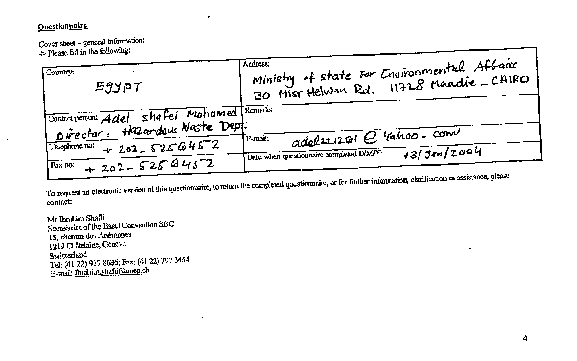

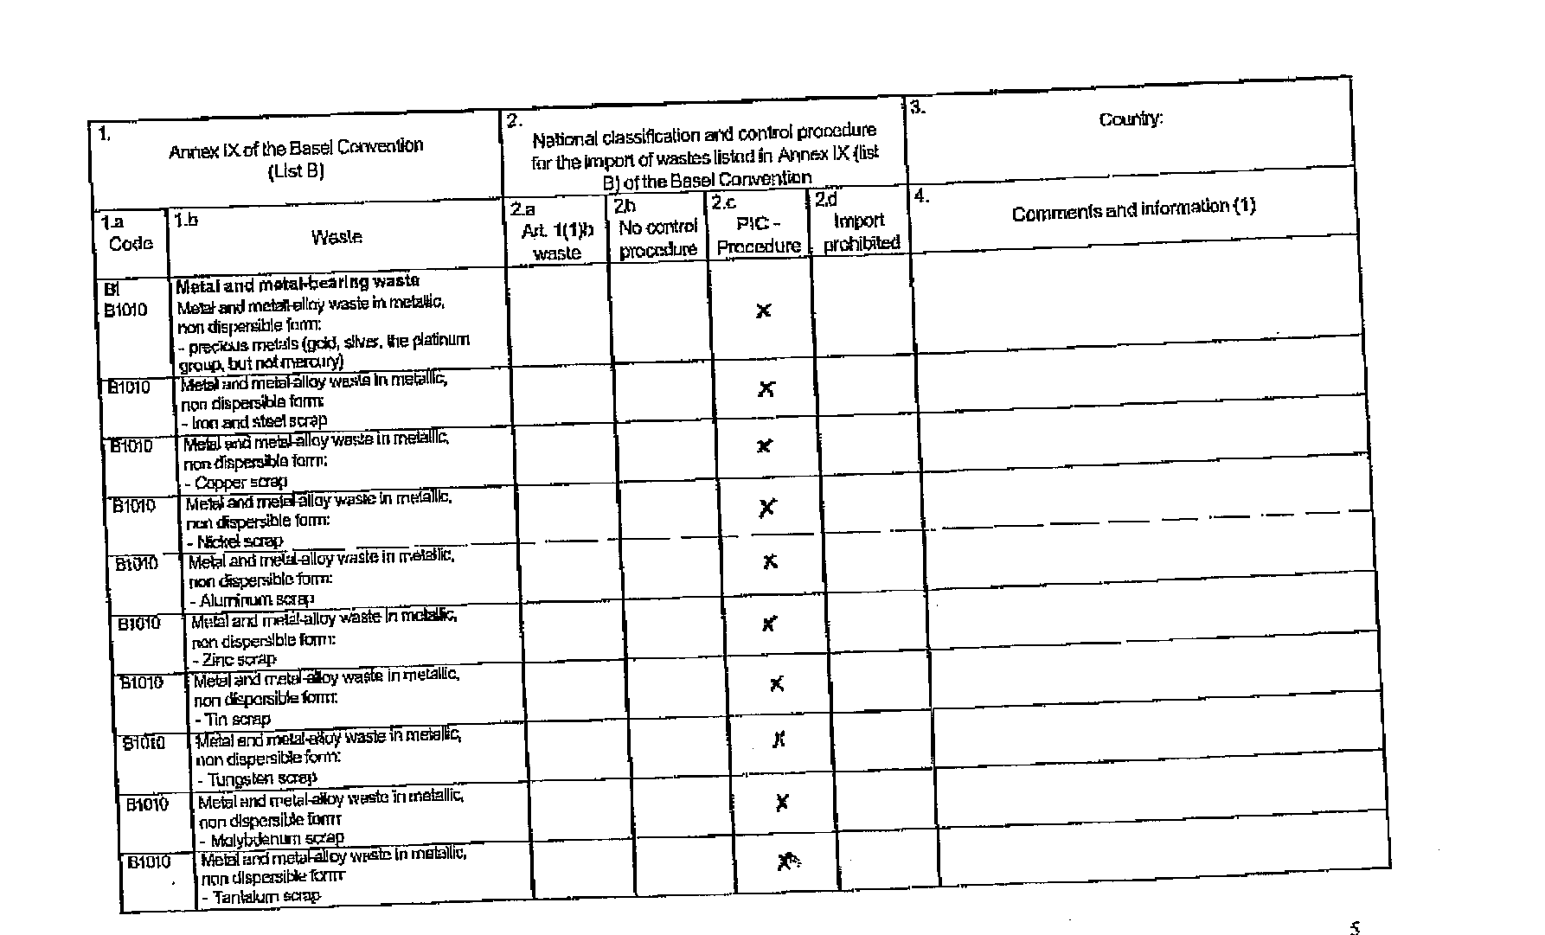

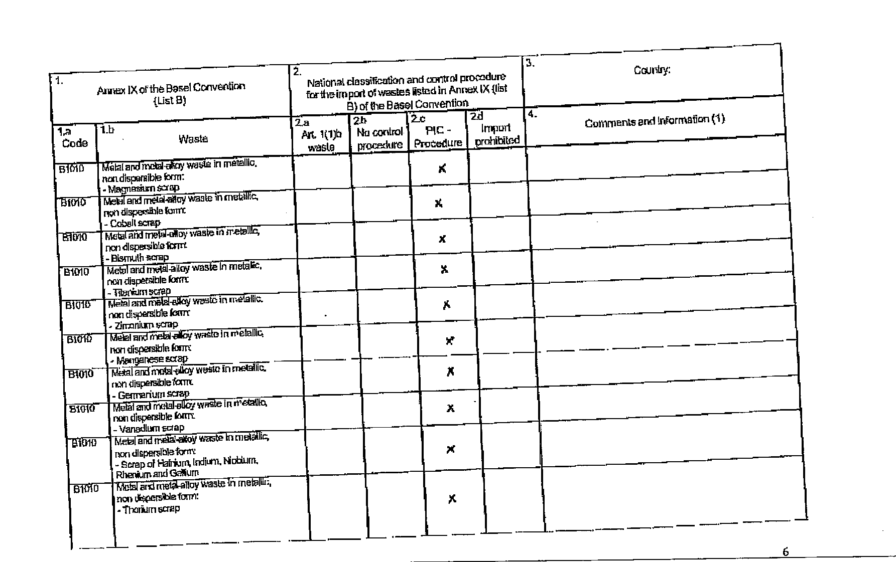

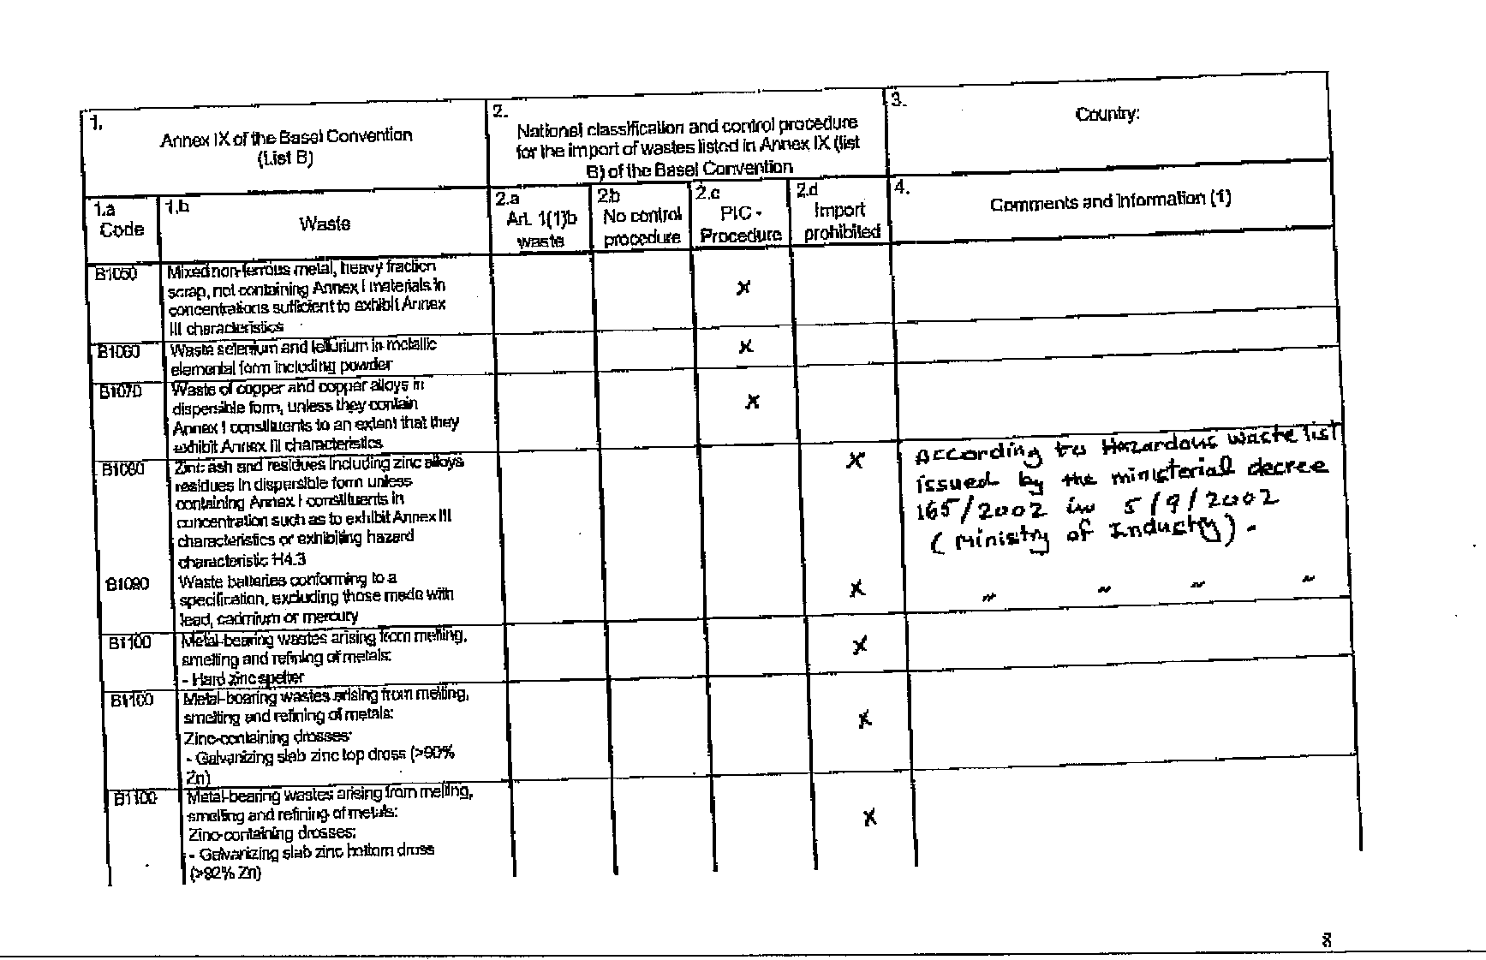

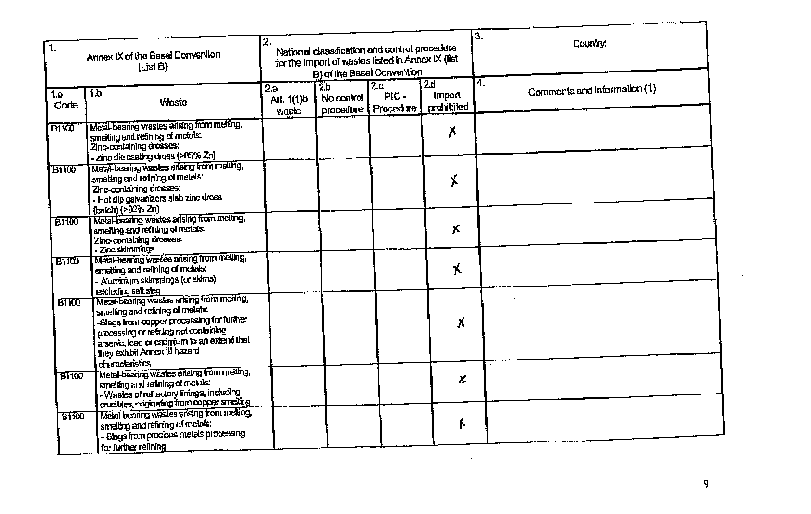

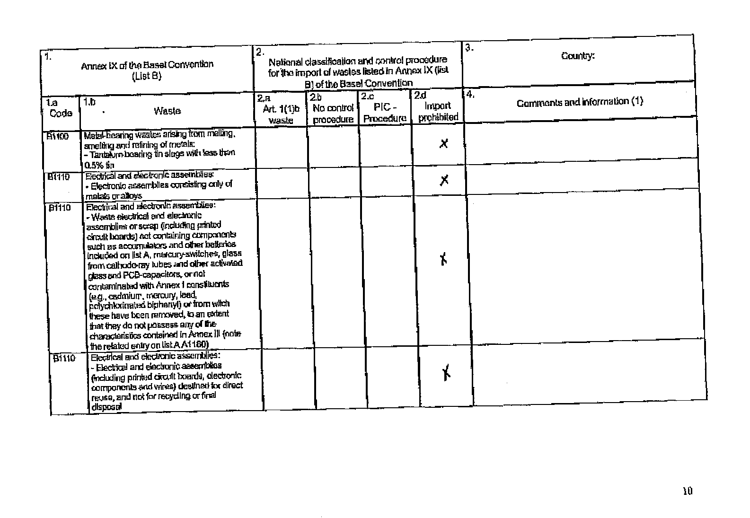

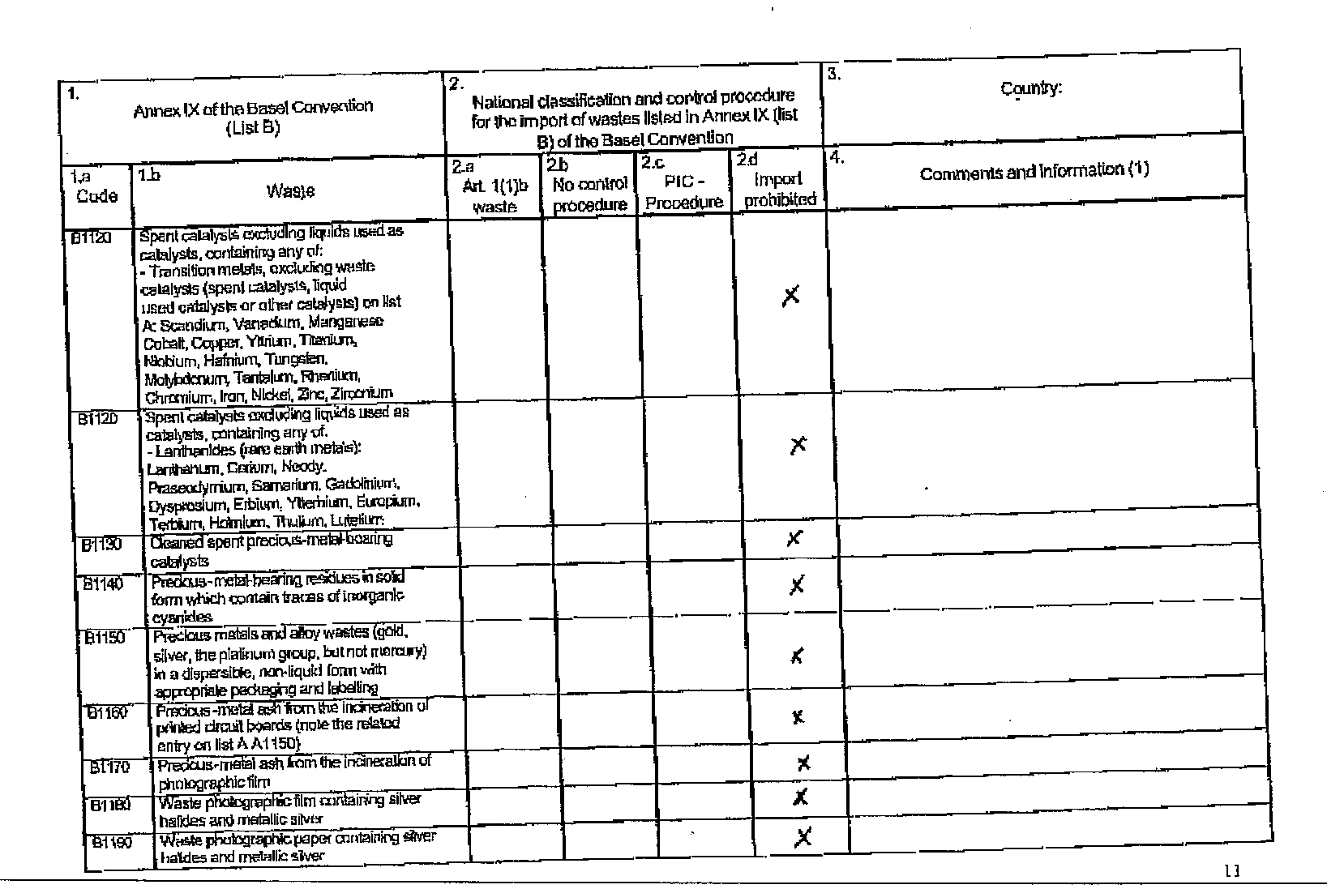

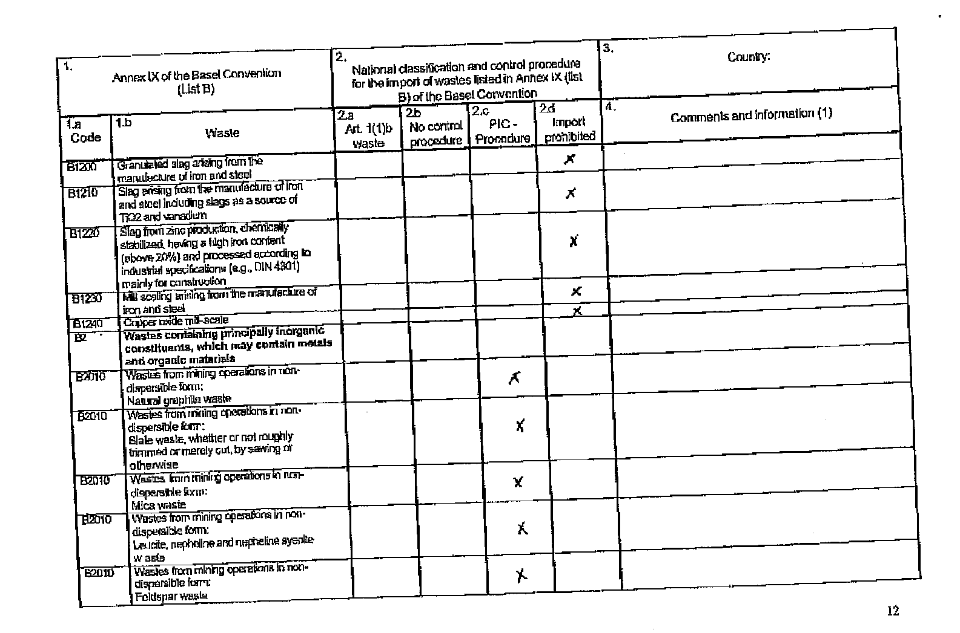

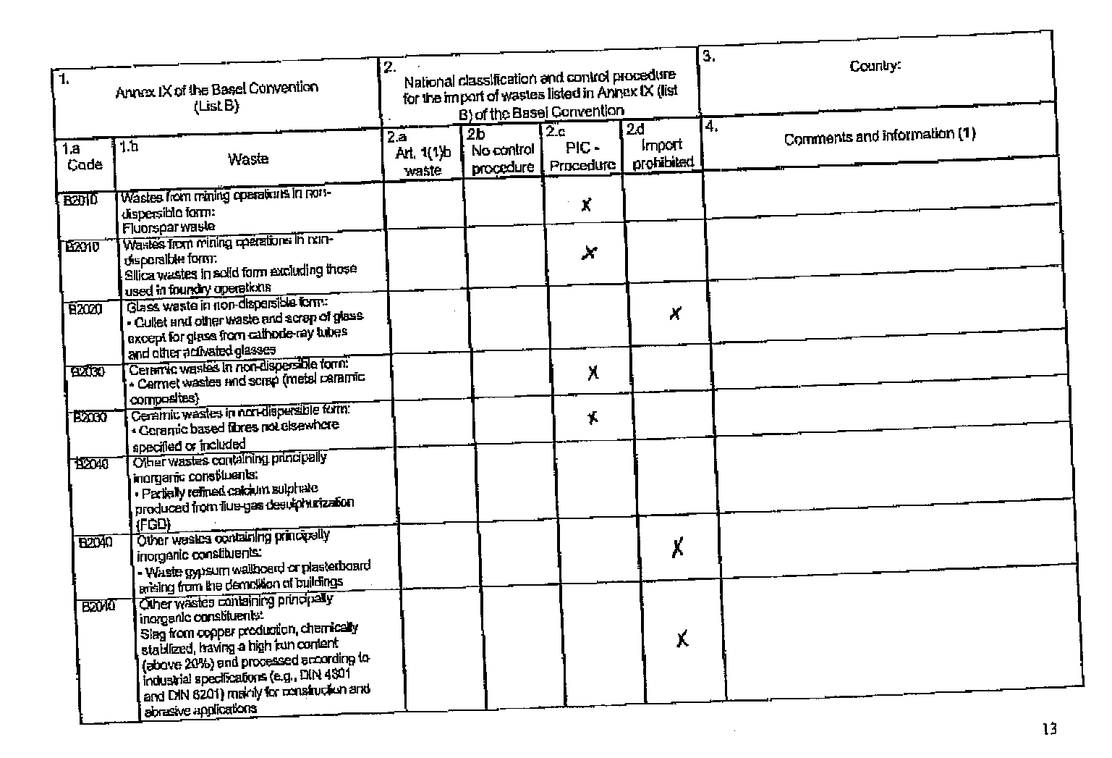

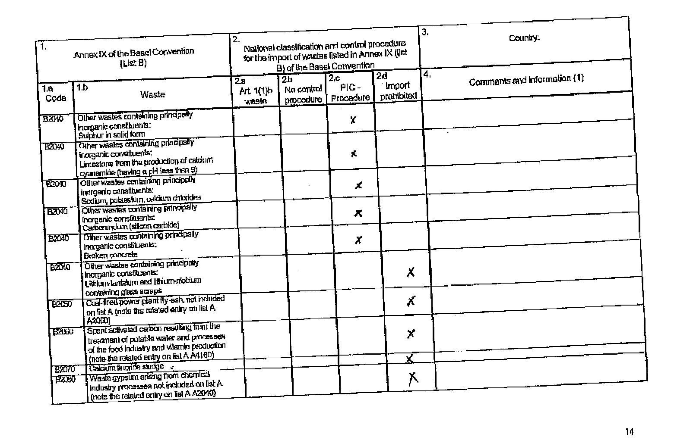

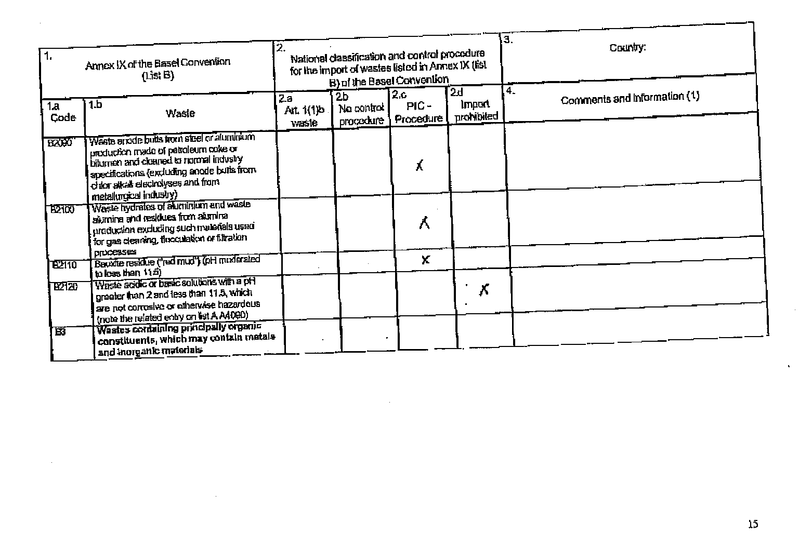

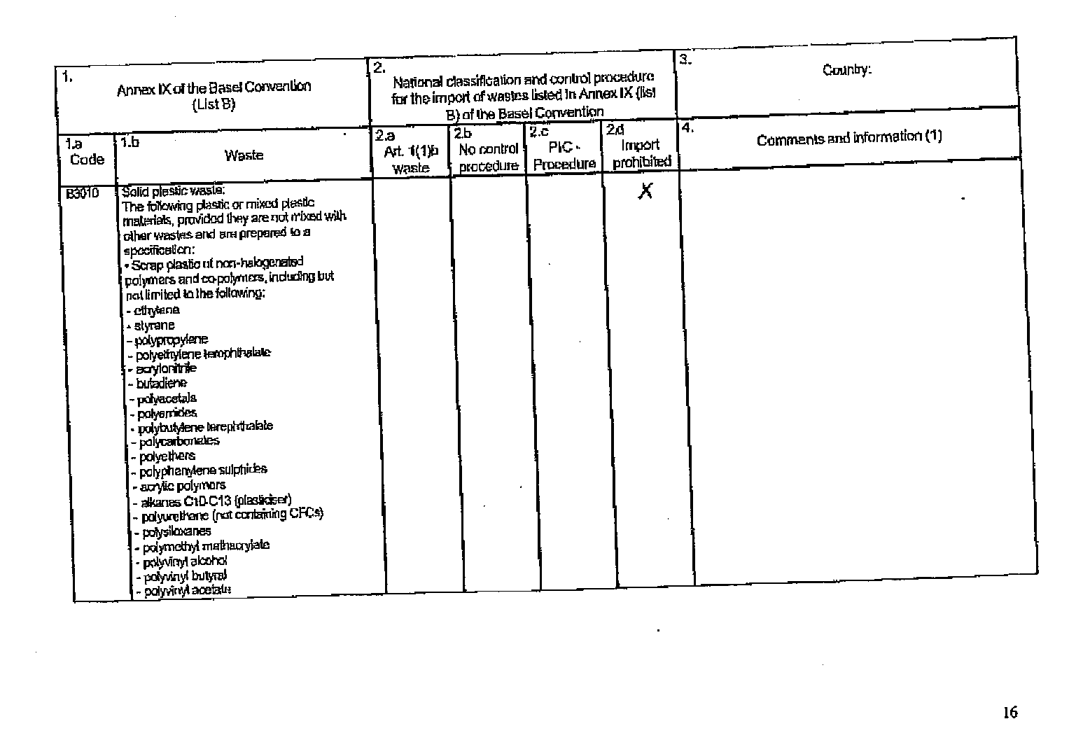

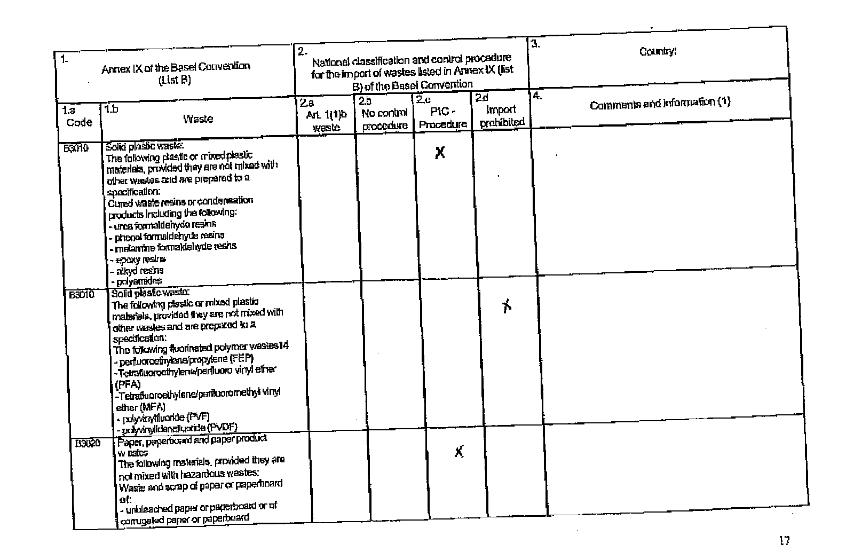

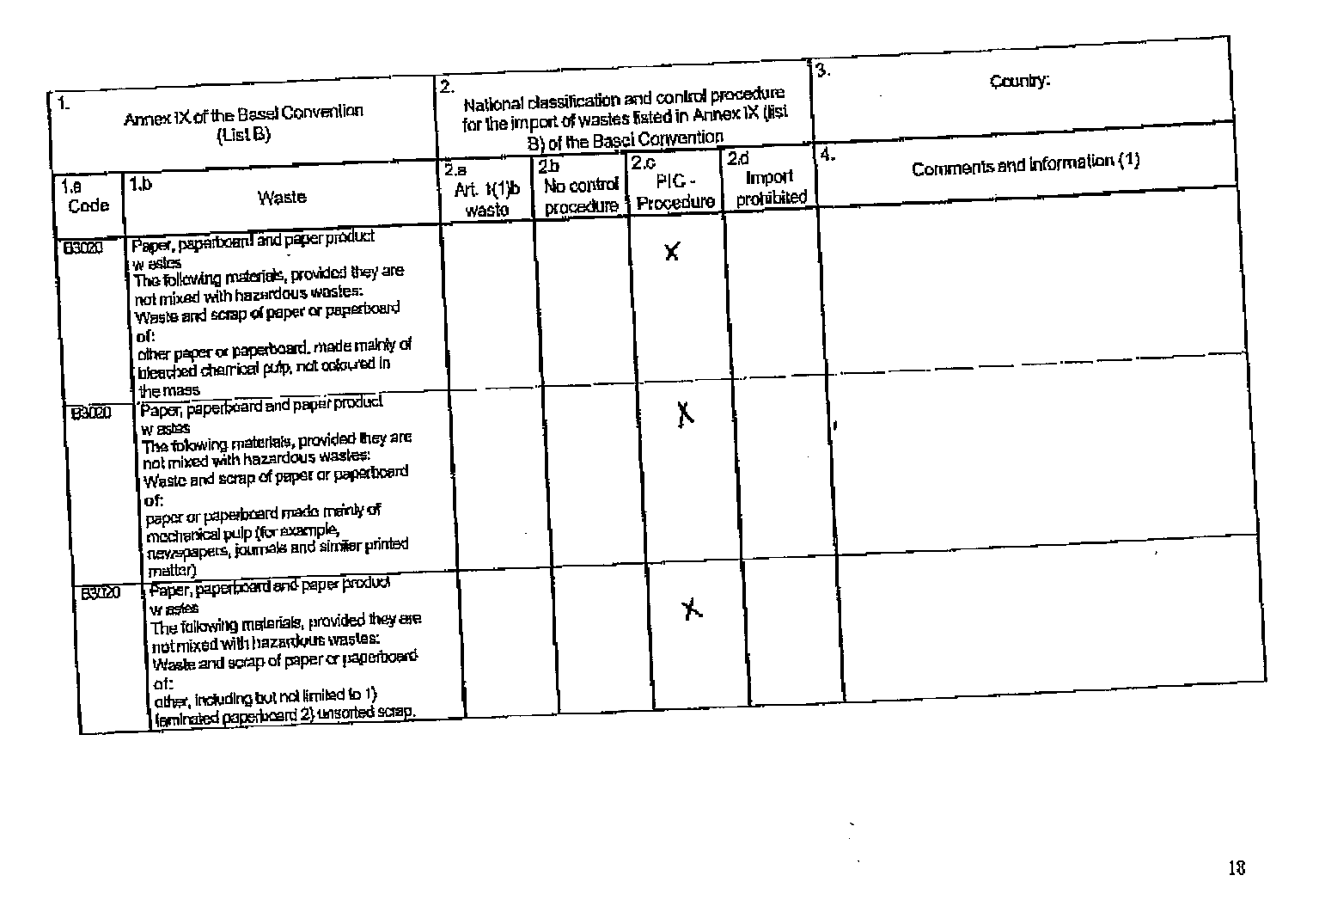
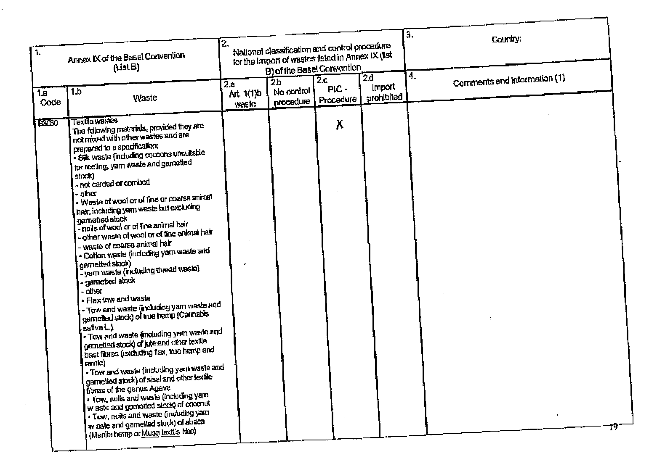

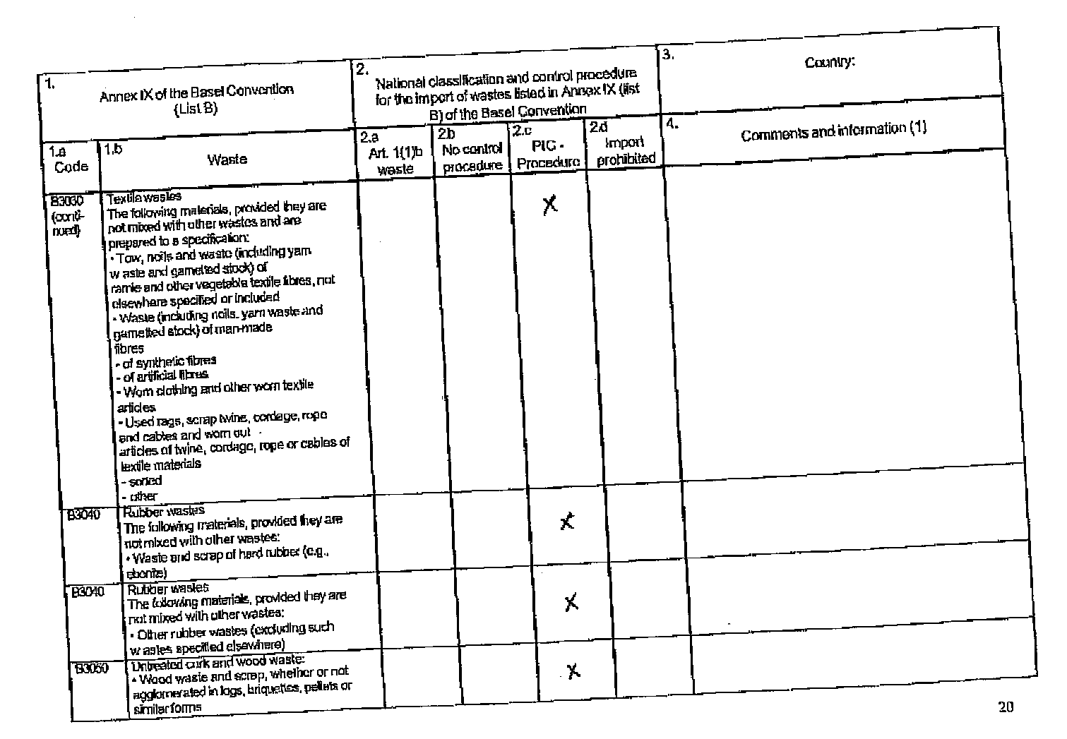

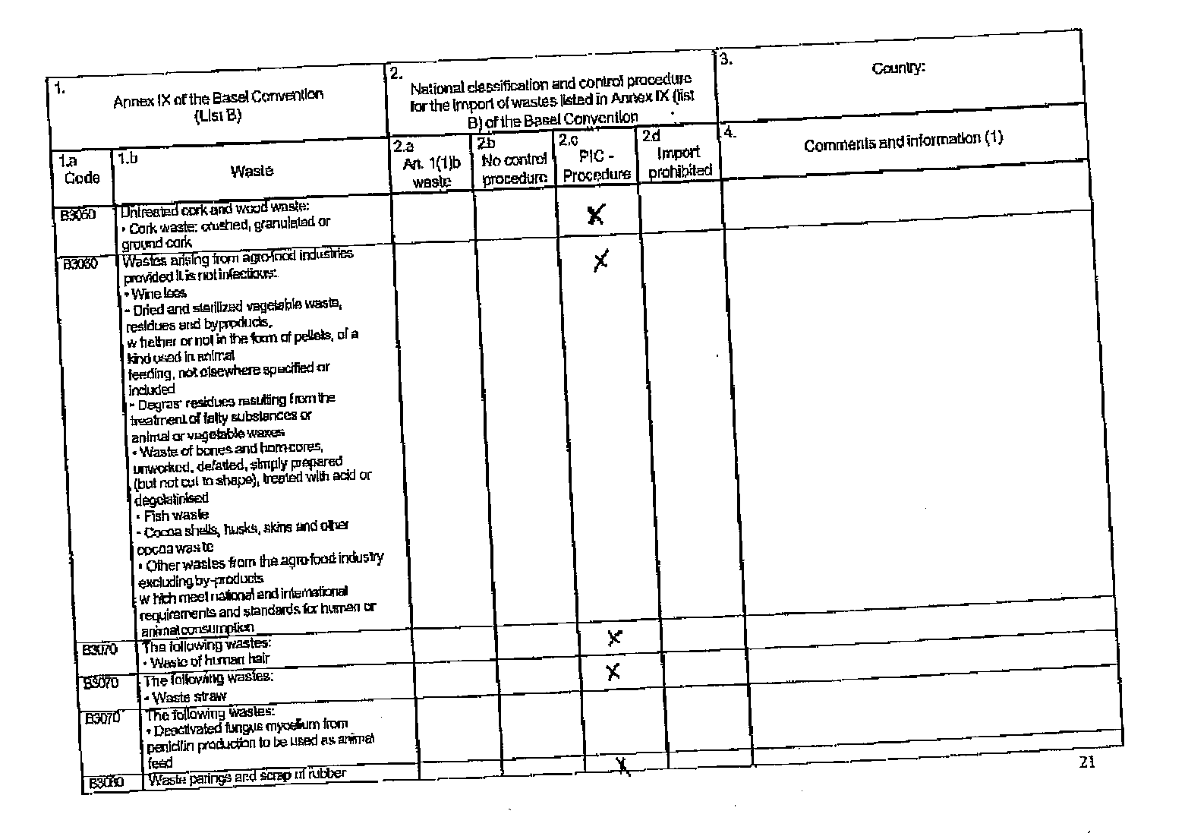

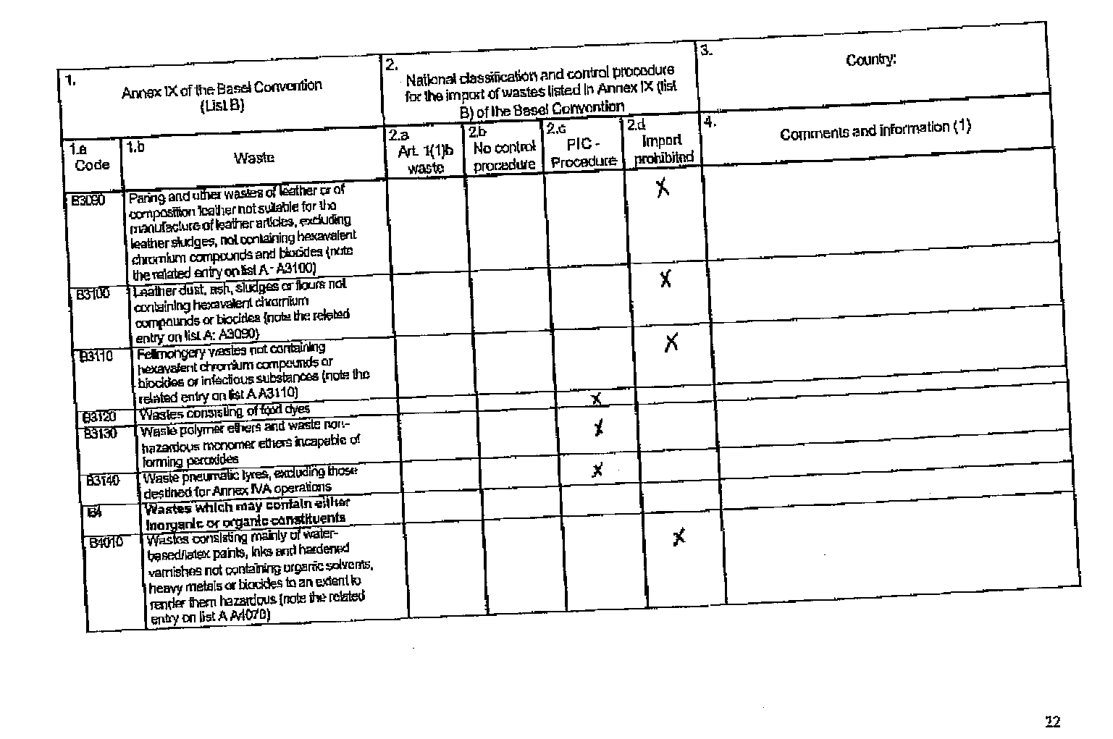

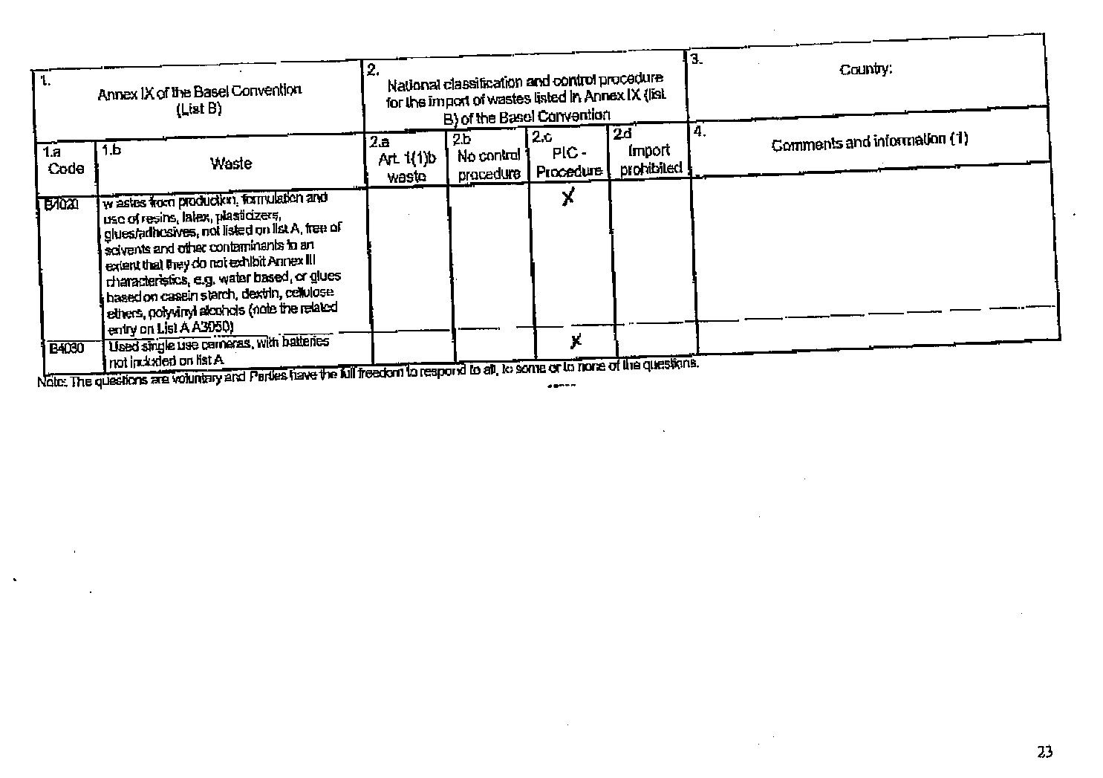

Poland

Questionnaire

Cover sheet - general information:
-> Please fill in the following:

Country:  POLAND | Address:  Chief Inspectorate for Environmental Protection  Wawelska St. 52/54
Contact person:  Włodzimierz Garczyński  Magda Gosk | Remarks
Telephone no:  +48 22 825 11 04  + 48 22 5792 729 | E-mail:  w.garczynski@gios.gov.pl  m.gosk@gios.gov.pl
Fax no:  + 48 22 8251104 | Date when questionnaire completed D/M/Y:  10.12.2003

To request an electronic version of this questionnaire, to return the completed questionnaire, or for further information, clarification or assistance, please contact:

Mr Ibrahim Shafii
Secretariat of the Basel Convention SBC
15, chemin des Anémones
1219 Châtelaine, Geneva
Switzerland
Tel: (41 22) 917 8636; Fax: (41 22) 797 3454
E-mail: ibrahim.shafii@unep.ch

1.  Annex IX of the Basel Convention  (List B) |  | 2.  National classification and control procedure for the import of wastes listed in Annex IX (list B) of the Basel Convention |  |  |  | 3.  Country:
1.a  Code | 1.b  Waste | 2.a  Art. 1(1)b waste | 2.b  No control procedure | 2.c  PIC -Procedure | 2.d  Import prohibited | 4.  Comments and information (1)
B1 | Metal and metal-bearing waste
B1010 | Metal and metall-alloy waste in metallic, non dispersible form:  - precious metals (gold, silver, the platinum group, but not mercury) |  | X
B1010 | Metal and metal-alloy waste in metallic, non dispersible form:  - Iron and steel scrap |  | X
B1010 | Metal and metal-alloy waste in metallic, non dispersible form:  - Copper scrap |  | X
B1010 | Metal and metal-alloy waste in metallic, non dispersible form:  - Nickel scrap |  | X
B1010 | Metal and metal-alloy waste in metallic, non dispersible form:  - Aluminum scrap |  | X
B1010 | Metal and metal-alloy waste in metallic, non dispersible form:  - Zinc scrap |  | X
B1010 | Metal and metal-alloy waste in metallic, non dispersible form:  - Tin scrap |  | X
B1010 | Metal and metal-alloy waste in metallic, non dispersible form:  - Tungsten scrap |  | X
B1010 | Metal and metal-alloy waste in metallic, non dispersible form:  - Molybdenum scrap |  | X
B1010 | Metal and metal-alloy waste in metallic, non dispersible form:  - Tantalum scrap |  | X
B1010 | Metal and metal-alloy waste in metallic, non dispersible form:  - Magnesium scrap |  | X
B1010 | Metal and metal-alloy waste in metallic, non dispersible form:  - Cobalt scrap |  | X
B1010 | Metal and metal-alloy waste in metallic, non dispersible form:  - Bismuth scrap |  | X
B1010 | Metal and metal-alloy waste in metallic, non dispersible form:  - Titanium scrap |  | X
B1010 | Metal and metal-alloy waste in metallic, non dispersible form:  - Zirconium scrap |  | X
B1010 | Metal and metal-alloy waste in metallic, non dispersible form:  - Manganese scrap |  | X
B1010 | Metal and metal-alloy waste in metallic, non dispersible form:  - Germanium scrap |  | X
B1010 | Metal and metal-alloy waste in metallic, non dispersible form:  - Vanadium scrap |  | X
B1010 | Metal and metal-alloy waste in metallic, non dispersible form:  - Scrap of Hafnium, Indium, Niobium, Rhenium and Gallium |  | X
B1010 | Metal and metal-alloy waste in metallic, non dispersible form:  - Thorium scrap |  |  | X
B1010 | Metal and metal-alloy waste in metallic, non dispersible form:  - Rare earth’s scrap |  | X
B1020 | Clean uncontaminated metal scrap, including alloys, in bulk finished form (sheet, plate, beams, rods, etc.), of:  - Antimony scrap |  | X
B1020 | Clean uncontaminated metal scrap, including alloys, in bulk finished form (sheet, plate, beams, rods, etc.), of:  - Beryllium scrap |  | X
B1020 | Clean uncontaminated metal scrap, including alloys, in bulk finished form (sheet, plate, beams, rods, etc.), of:  - Cadmium scrap |  |  | X
B1020 | Clean uncontaminated metal scrap, including alloys, in bulk finished form (sheet, plate, beams, rods, etc.), of:  - Lead scrap (but excluding lead-acid batteries) |  | X
B1020 | Clean uncontaminated metal scrap, including alloys, in bulk finished form (sheet, plate, beams, rods, etc.), of:  - Selenium scrap |  | X
B1020 | Clean uncontaminated metal scrap, including alloys, in bulk finished form (sheet, plate, beams, rods, etc.), of:  - Tellurium scrap |  | X
B1030 | Refractory metals containing residues |  |  | X
B1040 | Scrap assemblies from electrical power generation not contaminated with lubricating oil, PCB or PCT to an extent to  render them hazardous |  |  | X
B1050 | Mixed non-ferrous metal, heavy fraction scrap, not containing Annex I materials in concentrations sufficient to exhibit Annex  III characteristics |  |  | X
B1060 | Waste selenium and tellurium in metallic elemental form including powder |  | X
B1070 | Waste of copper and copper alloys in dispersible form, unless they contain Annex I constituents to an extent that they exhibit Annex III characteristics |  | X
B1080 | Zinc ash and residues including zinc alloys residues in dispersible form unless containing Annex I constituents in  concentration such as to exhibit Annex III characteristics or exhibiting hazard characteristic H4.3 |  |  | X
B1090 | Waste batteries conforming to a specification, excluding those made with lead, cadmium or mercury |  |  | X
B1100 | Metal-bearing wastes arising from melting, smelting and refining of metals:  - Hard zinc spelter |  | X
B1100 | Metal-bearing wastes arising from melting, smelting and refining of metals:  Zinc-containing drosses:  - Galvanizing slab zinc top dross (>90% Zn) |  | X
B1100 | Metal-bearing wastes arising from melting, smelting and refining of metals:  Zinc-containing drosses:  - Galvanizing slab zinc bottom dross (>92% Zn) |  | X
B1100 | Metal-bearing wastes arising from melting, smelting and refining of metals:  Zinc-containing drosses:  - Zinc die casting dross (>85% Zn) |  | X
B1100 | Metal-bearing wastes arising from melting, smelting and refining of metals:  Zinc-containing drosses:  - Hot dip galvanizers slab zinc dross (batch) (>92% Zn) |  | X
B1100 | Metal-bearing wastes arising from melting, smelting and refining of metals:  Zinc-containing drosses:  - Zinc skimmings |  | X
B1100 | Metal-bearing wastes arising from melting, smelting and refining of metals:  - Aluminium skimmings (or skims) excluding salt slag |  | X
B1100 | Metal-bearing wastes arising from melting, smelting and refining of metals:  -Slags from copper processing for further processing or refining not containing arsenic, lead or cadmium to an extend that they exhibit Annex III hazard characteristics |  | X
B1100 | Metal-bearing wastes arising from melting, smelting and refining of metals:  - Wastes of refractory linings, including crucibles, originating from copper smelting |  | X
B1100 | Metal-bearing wastes arising from melting, smelting and refining of metals:  - Slags from precious metals processing for further refining |  |  | X
B1100 | Metal-bearing wastes arising from melting, smelting and refining of metals:  - Tantalum-bearing tin slags with less than 0.5% tin |  |  | X
B1110 | Electrical and electronic assemblies:  - Electronic assemblies consisting only of metals or alloys |  |  | X
B1110 | Electrical and electronic assemblies:  - Waste electrical and electronic assemblies or scrap (including printed circuit boards) not containing components such as accumulators and other batteries included on list A, mercury-switches, glass from cathode-ray tubes and other activated  glass and PCB-capacitors, or not contaminated with Annex I constituents (e.g., cadmium, mercury, lead, polychlorinated biphenyl) or from which these have been removed, to an extent that they do not possess any of the characteristics contained in Annex III (note the related entry on list A A1180) |  |  | X
B1110 | Electrical and electronic assemblies:  - Electrical and electronic assemblies (including printed circuit boards, electronic components and wires) destined for direct reuse, and not for recycling or final disposal |  |  | X
B1120 | Spent catalysts excluding liquids used as catalysts, containing any of:  - Transition metals, excluding waste  catalysts (spent catalysts, liquid  used catalysts or other catalysts) on list  A: Scandium, Vanadium, Manganese  Cobalt, Copper, Yttrium, Titanium, Niobium, Hafnium, Tungsten, Molybdenum, Tantalum, Rhenium, Chromium, Iron, Nickel, Zinc, Zirconium |  |  | X
B1120 | Spent catalysts excluding liquids used as catalysts, containing any of:  - Lanthanides (rare earth metals):  Lanthanum, Cerium, Neody, Praseodymium, Samarium, Gadolinium, Dysprosium, Erbium, Ytterbium, Europium, Terbium, Holmium, Thulium, Lutetium |  |  | X
B1130 | Cleaned spent precious-metal-bearing catalysts |  |  | X
B1140 | Precious-metal-bearing residues in solid form which contain traces of inorganic cyanides |  |  | X
B1150 | Precious metals and alloy wastes (gold, silver, the platinum group, but not mercury) in a dispersible, non-liquid form with appropriate packaging and labelling |  |  | X
B1160 | Precious-metal ash from the incineration of printed circuit boards (note the related entry on list A A1150) |  |  | X
B1170 | Precious-metal ash from the incineration of photographic film |  |  | X
B1180 | Waste photographic film containing silver halides and metallic silver |  |  | X
B1190 | Waste photographic paper containing silver halides and metallic silver |  |  | X
B1200 | Granulated slag arising from the manufacture of iron and steel |  | X
B1210 | Slag arising from the manufacture of iron and steel including slags as a source of TiO2 and vanadium |  |  | X
B1220 | Slag from zinc production, chemically stabilized, having a high iron content (above 20%) and processed according to industrial specifications (e.g., DIN 4301) mainly for construction |  |  | X
B1230 | Mill scaling arising from the manufacture of iron and steel |  |  | X
B1240 | Copper oxide mill-scale |  |  | X
B2 | Wastes containing principally inorganic constituents, which may contain metals and organic materials
B2010 | Wastes from mining operations in non-dispersible form:  Natural graphite waste |  |  | X
B2010 | Wastes from mining operations in non-dispersible form:  Slate waste, whether or not roughly trimmed or merely cut, by sawing or otherwise |  |  | X
B2010 | Wastes from mining operations in non-dispersible form:  Mica waste |  |  | X
B2010 | Wastes from mining operations in non-dispersible form:  Leucite, nepheline and nepheline syenite waste |  |  | X
B2010 | Wastes from mining operations in non-dispersible form:  Feldspar waste |  |  | X
B2010 | Wastes from mining operations in non-dispersible form:  Fluorspar waste |  |  | X
B2010 | Wastes from mining operations in non-dispersible form:  Silica wastes in solid form excluding those used in foundry operations |  |  | X
B2020 | Glass waste in non-dispersible form:  • Cullet and other waste and scrap of glass except for glass from cathode-ray tubes and other activated glasses |  |  | X
B2030 | Ceramic wastes in non-dispersible form:  • Cermet wastes and scrap (metal ceramic composites) |  |  | X
B2030 | Ceramic wastes in non-dispersible form:  • Ceramic based fibres not elsewhere specified or included |  |  | X
B2040 | Other wastes containing principally inorganic constituents:  • Partially refined calcium sulphate produced from flue-gas desulphurization (FGD) |  |  | X
B2040 | Other wastes containing principally inorganic constituents:  • Waste gypsum wallboard or plasterboard arising from the demolition of buildings |  |  | X
B2040 | Other wastes containing principally inorganic constituents:  Slag from copper production, chemically stabilized, having a high iron content (above 20%) and processed according to industrial specifications (e.g., DIN 4301 and DIN 8201) mainly for construction and abrasive applications |  |  | X
B2040 | Other wastes containing principally inorganic constituents:  Sulphur in solid form |  |  | X
B2040 | Other wastes containing principally inorganic constituents:  Limestone from the production of calcium cyanamide (having a pH less than 9) |  |  | X
B2040 | Other wastes containing principally inorganic constituents:  Sodium, potassium, calcium chlorides |  |  | X
B2040 | Other wastes containing principally inorganic constituents:  Carborundum (silicon carbide) |  |  | X
B2040 | Other wastes containing principally inorganic constituents:  Broken concrete |  |  | X
B2040 | Other wastes containing principally inorganic constituents:  Lithium-tantalum and lithium-niobium containing glass scraps |  |  | X
B2050 | Coal-fired power plant fly-ash, not included on list A (note the related entry on list A A2060) |  |  | X
B2060 | Spent activated carbon resulting from the treatment of potable water and processes of the food industry and vitamin production  (note the related entry on list A A4160) |  |  | X
B2070 | Calcium fluoride sludge |  |  | X
B2080 | Waste gypsum arising from chemical industry processes not included on list A (note the related entry on list A A2040) |  |  | X
B2090 | Waste anode butts from steel or aluminium production made of petroleum coke or bitumen and cleaned to normal industry  specifications (excluding anode butts from chlor alkali electrolyses and from metallurgical industry) |  |  | X
B2100 | Waste hydrates of aluminium and waste alumina and residues from alumina production excluding such materials used for gas cleaning, flocculation or filtration processes |  |  | X
B2110 | Bauxite residue ("red mud") (pH moderated to less than 11.5) |  |  | X
B2120 | Waste acidic or basic solutions with a pH greater than 2 and less than 11.5, which are not corrosive or otherwise hazardous (note the related entry on list A A4090) |  |  | X
B3 | Wastes containing principally organic constituents, which may contain metals and inorganic materials
B3010 | Solid plastic waste:  The following plastic or mixed plastic materials, provided they are not mixed with other wastes and are prepared to a specification:  • Scrap plastic of non-halogenated polymers and co-polymers, including but not limited to the following:  - ethylene  - styrene  - polypropylene  - polyethylene terephthalate  - acrylonitrile  - butadiene  - polyacetals  - polyamides  - polybutylene terephthalate  - polycarbonates  - polyethers  - polyphenylene sulphides  - acrylic polymers  - alkanes C10-C13 (plasticiser)  - polyurethane (not containing CFCs)  - polysiloxanes  - polymethyl methacrylate  - polyvinyl alcohol  - polyvinyl butyral  - polyvinyl acetate |  |  | X
B3010 | Solid plastic waste:  The following plastic or mixed plastic materials, provided they are not mixed with other wastes and are prepared to a specification:  Cured waste resins or condensation products including the following:  - urea formaldehyde resins  - phenol formaldehyde resins  - melamine formaldehyde resins  - epoxy resins  - alkyd resins  - polyamides |  |  | X
B3010 | Solid plastic waste:  The following plastic or mixed plastic materials, provided they are not mixed with other wastes and are prepared to a specification:  The following fluorinated polymer wastes14  - perfluoroethylene/propylene (FEP)  -Tetrafluoroethylene/perfluoro vinyl ether (PFA)  -Tetrafluoroethylene/perfluoromethyl vinyl ether (MFA)  - polyvinylfluoride (PVF)  - polyvinylidenefluoride (PVDF) |  |  | X
B3020 | Paper, paperboard and paper product wastes  The following materials, provided they are not mixed with hazardous wastes:  Waste and scrap of paper or paperboard of:  - unbleached paper or paperboard or of corrugated paper or paperboard |  |  | X
B3020 | Paper, paperboard and paper product wastes  The following materials, provided they are not mixed with hazardous wastes:  Waste and scrap of paper or paperboard of:  other paper or paperboard, made mainly of bleached chemical pulp, not coloured in the mass |  |  | X
B3020 | Paper, paperboard and paper product wastes  The following materials, provided they are not mixed with hazardous wastes:  Waste and scrap of paper or paperboard of:  paper or paperboard made mainly of mechanical pulp (for example, newspapers, journals and similar printed matter) |  |  | X
B3020 | Paper, paperboard and paper product wastes  The following materials, provided they are not mixed with hazardous wastes:  Waste and scrap of paper or paperboard of:  other, including but not limited to 1) laminated paperboard 2) unsorted scrap. |  |  | X
B3030 | Textile wastes  The following materials, provided they are not mixed with other wastes and are prepared to a specification:  • Silk waste (including cocoons unsuitable for reeling, yarn waste and garnetted stock)  - not carded or combed  - other  • Waste of wool or of fine or coarse animal hair, including yarn waste but excluding garnetted stock  - noils of wool or of fine animal hair  - other waste of wool or of fine animal hair  - waste of coarse animal hair  • Cotton waste (including yarn waste and garnetted stock)  - yarn waste (including thread waste)  - garnetted stock  - other  • Flax tow and waste  • Tow and waste (including yarn waste and garnetted stock) of true hemp (Cannabis sativa L.)  • Tow and waste (including yarn waste and garnetted stock) of jute and other textile bast fibres (excluding flax, true hemp and ramie)  • Tow and waste (including yarn waste and garnetted stock) of sisal and other textile fibres of the genus Agave  • Tow, noils and waste (including yarn waste and garnetted stock) of coconut  • Tow, noils and waste (including yarn waste and garnetted stock) of abaca (Manila hemp or Musa textilis Nee) |  | X* |  |  | *Excluding:  • Waste (including noils, yarn waste and garnetted stock) of man-made  fibres  - of synthetic fibres  - of artificial fibres  • Worn clothing and other worn textile articles  • Used rags, scrap twine, cordage, rope and cables and worn out  articles of twine, cordage, rope or cables of textile materials  - sorted  - other  Above mentioned wastes are covered by PIC-procedure.
B3030  (conti-nued) | Textile wastes  The following materials, provided they are not mixed with other wastes and are prepared to a specification:  • Tow, noils and waste (including yarn waste and garnetted stock) of  ramie and other vegetable textile fibres, not elsewhere specified or included  • Waste (including noils, yarn waste and garnetted stock) of man-made  fibres  - of synthetic fibres  - of artificial fibres  • Worn clothing and other worn textile articles  • Used rags, scrap twine, cordage, rope and cables and worn out  articles of twine, cordage, rope or cables of textile materials  - sorted  - other
B3040 | Rubber wastes  The following materials, provided they are not mixed with other wastes:  • Waste and scrap of hard rubber (e.g., ebonite) |  |  | X
B3040 | Rubber wastes  The following materials, provided they are not mixed with other wastes:  • Other rubber wastes (excluding such wastes specified elsewhere) |  |  | X
B3050 | Untreated cork and wood waste:  • Wood waste and scrap, whether or not agglomerated in logs, briquettes, pellets or similar forms |  |  | X
B3050 | Untreated cork and wood waste:  • Cork waste: crushed, granulated or ground cork |  |  | X
B3060 | Wastes arising from agro-food industries provided it is not infectious:  • Wine lees  • Dried and sterilized vegetable waste, residues and byproducts,  whether or not in the form of pellets, of a kind used in animal  feeding, not elsewhere specified or included  • Degras: residues resulting from the treatment of fatty substances or  animal or vegetable waxes  • Waste of bones and horn-cores, unworked, defatted, simply prepared  (but not cut to shape), treated with acid or degelatinised  • Fish waste  • Cocoa shells, husks, skins and other cocoa waste  • Other wastes from the agro-food industry excluding by-products  which meet national and international requirements and standards for human or animal consumption |  | X** |  |  | **Excluding:  • Wine lees  • Degras: residues resulting from the treatment of fatty substances or animal or vegetable waxes  • Waste of bones and horn-cores, unworked, defatted, simply prepared (but not cut to shape), treated with acid or degelatinised  • Fish waste  • Other wastes from the agro-food industry excluding by-products  which meet national and international requirements and standards for human or animal consumption  Above mentioned wastes are covered by PIC-procedure
B3070 | The following wastes:  • Waste of human hair |  |  | X
B3070 | The following wastes:  • Waste straw |  |  | X
B3070 | The following wastes:  • Deactivated fungus mycelium from penicillin production to be used as animal feed |  |  | X
B3080 | Waste parings and scrap of rubber |  |  | X
B3090 | Paring and other wastes of leather or of composition leather not suitable for the manufacture of leather articles, excluding  leather sludges, not containing hexavalent chromium compounds and biocides (note the related entry on list A : A3100) |  |  | X
B3100 | Leather dust, ash, sludges or flours not containing hexavalent chromium compounds or biocides (note the related entry on list A: A3090) |  |  | X
B3110 | Fellmongery wastes not containing hexavalent chromium compounds or biocides or infectious substances (note the  related entry on list A A3110) |  |  | X
B3120 | Wastes consisting of food dyes |  |  | X
B3130 | Waste polymer ethers and waste non-hazardous monomer ethers incapable of forming peroxides |  |  | X
B3140 | Waste pneumatic tyres, excluding those destined for Annex IVA operations |  |  | X
B4 | Wastes which may contain either inorganic or organic constituents
B4010 | Wastes consisting mainly of water-based/latex paints, inks and hardened varnishes not containing organic solvents, heavy metals or biocides to an extent to render them hazardous (note the related entry on list A A4070) |  |  | X
B4020 | wastes from production, formulation and use of resins, latex, plasticizers, glues/adhesives, not listed on list A, free of solvents and other contaminants to an extent that they do not exhibit Annex III characteristics, e.g. water based, or glues based on casein starch, dextrin, cellulose ethers, polyvinyl alcohols (note the related entry on List A A3050) |  |  | X
B4030 | Used single use cameras, with batteries not included on list A |  |  | X
Note: The questions are voluntary and Parties have the full freedom to respond to all, to some or to none of the questions.

______

 UNEP/CHW/OEWG/3/1.

